Table of Contents

Part 1. Behavior Questions: 3

Part 1.1 Introduce yourself: 3

It was a cross-architecture, and hyper-growth environment where priorities shifted fast, so commonly my responsibilities was dealing with complicated requirements from cutting-edge IoT/Cloud product team and account team, like deliver customized features, prototype, world-class showcase against aggressive schedule, with software development, communication, leadership skills and creativity. 3

Part 2. Experience 4

2.0 Summary 4

2.1 Previous industrial experience 4

2.1.1 Smart Office-IoT and cloud platform: 4

2.1.2 [Leadership] IoT in Manufacturing to handle potential dangers 5

2.2.0 Summary & Motivation: 8

2.2.1 Neuron Imaging Research-Harvard RA 8

2.2.2 Project: Genome simulation & Dendrogram visualization + Broad Institute: 9

2.2.3 [Leadership] Project: Automatic platform for data training and prediction - with another industrial company/NEU, RA: 10

2.2.4 NLP Project_Transportation + Twitter Sentiment Analysis: 11

2.2.5 NLP Project 2: NLP+Amazon Review+Word2Vec: 12

2.2.6 NLP Project-Yelp Review classification: 12

Part 3. Other Behavior Questions: 15

Part 4. Plan: 15

4.1 Short term: 15

4.2 Long term goal: 15

Part 5. QA and Ending: 15

Part 6. WHY company? 16

6.1 Why DataRobot? 16

6.2 Why Accenture? 16

6.3 Why Amazon Alexa? 17

Part 7. Data position Interview 17

7.1 DS structure: 17

7.2 TECHQ_DS/ML 18

7.2.1 Supervisor & Unsupervised? 18

7.2.2 Interpretability-LIME 18

7.2.3 How to balance variance VS bias. 18

7.2.4 Explain random tree? What is the relationship within the sub-trees? 18

7.2.5 What is aggregation? 19

7.2.6 How to process categorical data? 20

7.2.7 Which model you are most familiar with? 21

7.3 TECHQ_NLP: 26

7.3.1 NLP processing structure: (See above) 26

7.3.2 Word2Vec: (See above) 26

7.3.3 Twitter real-time streaming: 26

7.3.4 RNN: 26

7.3.5. Other NLP interview questions: 27

7.4 TECHQ_Architecture, Pattern Design: 29

7.4.1. Design pattern: 29

7.4.2. Architecture: 34

7.4.3. How to increase scalability? 34

7.4.4. How to increase reliability? 34

7.4.5. Full software develop lifecycle: 34

- Code review; 34

- Source control management; 34

- Building process; 34

7.4.6. service-oriented architectures, 34

7.4.7. Map-reduce, 34

7.4.8. Distributed caching, 34

7.4.9. Load balancing 34

7.5 TECHQ_CODE: 34

7.5.1. Memory management work: 34

7.5.2. the most commonly used collections, libraries 34

7.5.3. Common algorithms: 34

7.5.3.1 Traversals, 34

7.5.3.2 Divide and conquer, 34

7.5.3.3 Breadth-first search vs. depth-first search and understand the tradeoffs for each. 34

7.5.3.4 Knowing the runtimes, 34

7.5.3.5 Theoretical limitations, 34

7.5.3.6 Basic implementation strategies of different classes of algorithms is more important than memorizing the specific details of any given algorithm. 34

7.5.4 Trade-offs between relational and non-relational databases: 34

7.6 TECHQ_Amazon’s most asked interview questions 34

7.6.1 (Heap) K largest elements from a big file or array. 34

7.6.2 (Hashing) Find a triplet a, b, c such that a^2 = b^2 + c^2. 35

7.6.3 Binary tree traversal questions: 36

Left view, right view, top view, bottom view, maximum of a level, minimum of a level, children sum property, diameter etc. 36

7.6.4 Convert a Binary tree to DLL 38

7.6.5 Lowest Common ancestor in a Binary Search Tree and Binary Tree. 38

7.6.6 Implement a stack with push(), pop() and min() in O(1) time. 38

7.6.7 Reverse a linked list in groups of size k – Practice here 38

7.6.8 Given two numbers represented by two linked lists, write a function that returns sum list – Practice here 38

7.6.9 Rotate a matrix by 90 degree. 38

7.6.10 Stock span problem 38

7.7 TECHQ_OS: 38

7.7.1 Processes: 38

7.7.2 Threads, 38

7.7.3 Synchronization, 38

7.7.4 Paging, 38

7.7.5 Multithreading 38

7.8 TECHQ_Network: 38

7.8.1. DNS lookup: 38

7.8.2. Socket connection: 38

# Part 1. Behavior Questions:

## Part 1.1 Introduce yourself:

**Good afternoon, Ziwei Wing Fan Speaking.**

**Glad to talk with you!**

**Basic:**

**I’ll graduate from Northeastern by Dec. with Master Degree**

**#Skillsets: data process, data science & visualization by python, database, software development.**

**“Responsible leader & member, curious & motivated who like challenges, punctual.”**

**I passed the ‘business development and program management’ training at Harvard with certification and the Global leadership certificate at Leadership program @Northeastern University**

**Working experience:**

Started off my career as system engineer/program manager with Cisco Systems in past 5 years in cross-architecture group. We always keep the customer top of mind to support some cutting-edge IoT product.

This hyper-growth environment where priorities shifted fast, my responsibilities was dealing with complicated requirements from account team & clients, like deliver customized features, prototype, world-class showcase against aggressive schedule, with software development, leadership skills and creativity.

# World-class showcase: IoT/Cloud in manufacturing, Collaboration solution for commercial & Service providers.

Clients support: clients in fields of (food manufacture), Service providers, banking.

Bridged between customer/account team, to help product team for improving.

-----------------------------

**Curiosity/Passion in DS/ML:**

The previous IoT experience drove me to learn more about DS/ML,

* Research programs @Harvard, and Broad Institute, regarding Medical data, genome & neuron image. (Python, R, data visualization, based operation on parallel computing)
* To figure out the potential pattern of neuron image, and genome mutation
* excited to pick up some new fields with my knowledge.
* Research Assistant @ Northeastern, automated DS/ML platform. Increase the flexibility & efficiency for data training & modeling. My advice regarding ML interpretability was taken by my group: for black box model to be more interpretable & understandable for non-expert.

# Part 2. Experience

### 2.0 Summary

I would talk about: Previous, ongoing

Previous industrial experience in several fields, enable me to understand business requirement better: transportation, manufacturing, etc.

Ongoing projects: Hands-on experience in data projects like build predictive models, in medical data, like genome, specific fields. SaaS platform.

### 2.1 Previous industrial experience

### 2.1.1 Smart Office-IoT and cloud platform:

Started off my career as system engineer/product manager with Cisco Systems.

#### 2.1.1.1 Responsible

* **System Engineer**
* IoT, cloud: Automation, customization and integration with my development skill:
* Building the ecosystem with account team with my interactive communication skill
* Train the partners

#### 2.1.1.2 Goal and issue:

**Goal:**

* Effectively scale the work space for employees, Easily monitor and control the energy
* Reduce the IT cost and the time spending in deployment individually.

**Issue:** We’ll set up a new branch with 500 new employees will start to work there …

* They need virtual work space for daily work, like virtual IP phone, instant message, virtual client and other account, even the individual preference in the lightness of his/her space.
* How many days will be spent to enable them get to work in these working spaces, from the manager approval, set up clients, and IP phone…’
* Hard to integrate the private cloud and collaboration solution to increase the IT efficiency🡪Reduce from 7 days to 10 mins.

#### 2.1.1.3 How:

* Customized features by java for cloud solution according to clients’ requirements after effective communication and exploration.
* Combined 2 features by C# and JavaScript, as one entire automated process by to trigger customized workflows:
  + - Made the portal to be more user-friendly used by one-click; (JavaScript)
    - Multiple processes the requests by integration with collaboration cloud and triggered the approval process.
    - Then visualize the resource usage, status by interaction with SQL Server.
  + (keep interactive communication with customers and account manager.)
* Integrated 3 partners’ solution & our solution to make process more flexible and smoother, by API/Restful.

#### 2.1.1.4 Result: (Was happy to see)

* Reduce from 7 days to 10 mins
* Deliver this punctually, and support the sales team to win the deals, 1 million deals.
* The case I supported was the 1st one to be the innovative solution integrated the cloud and collaboration.

### 2.1.2 [Leadership] IoT in Manufacturing to handle potential dangers

#### 2.1.2.1 Responsible-TME/PM:

* [Technical]
* Supported & customized Industrial IoT /edge computing solution to solve the critical & complex requirement from clients.
* co-working with other team, developed features, conducted PoC, prototype against the aggressive schedule.
* Align the requirement with solution, define, figure out and co-work with some stakeholders, like the enterprise network team, operation team.
* Customized features for clients in industrial environment: manufacturing, transportation, electronic grid etc.

[Business]

* Work closely with other teams, like business development team and build the strong relationship with partners & ecosystem across couple of fields
* analyzed the win cases, explored the potential opportunities with sales team
* Lead partner engineers to implement some IoT features;
* Train the clients’ and internal systems engineer after implementation
* Passionate in solving complex requirements in simpler way and bridged the technical engineers & non-technical stakeholders

#### 2.1.2.2 Issue & Goal:

“Interpreter from business logic to data tiers”

1. Scalability:

* Operation owners: visualize the 4 work plants status: emergency data and axis status: 1 US & Japan, 2 in China. More…

Integrate data visualization of all the work plants-Thingsboard

2. Smart-Automatic Workflow & context based:

* ‘What if an emergency happened in some assembly line and they didn’t get the alarm timely, like the temperature detected go up suddenly?
* What if the emergency didn’t get solved in time?
* What if any staff without training but get into the dangerous area?”

3. Challenges:

“A VARIETY of challenges from BUSINESS & TECHNIQUES”

* Management RISK:
  + (Partners could not sync-up/discuss on-site🡪Schedule risk)
  + 🡪Suggested co-work by webex, ! keep weekly updating
  + 🡪Setup a collaboration tool in the client’s branch for co-working as well
  + 🡪Motivate the group: Reviewing the goal, change different meeting environment, introduced partners to meet some resource they were interested in, talked about funny stuffs for relax
* URGENT requirement + No more manufacturing knowledgebase:

! align with the aggressive schedule🡪

* (Wrong way: Research by myself)
* Discuss with manufacturing experts in other teams: account team: real requirement
* Asked question when visited 2 clients about production line: Robotics, paper manufacturer.
* Asked my manager/stakeholders, the resource: ecosystem/partners
* Broke down the requirement and assign the tasks to different partners: the protocol part, connection part, integration part, deployment part.
* Evaluate the final option: complexity? Security? Stability etc.-->Ethernet and Longtooth/Wifi + filter the 3G/4G for poor reception
  + Co-work with each other: 3 partner companies
  + Rapidly learn from ecosystem:
* Learned behaviors that span multiple devices throughout the requirement
* Monitor + React in RISK!
* (Terrible: Insecure way + If workflow stuck in some step + could not handle timely…)
* Researched by discussion with partners: protocols (Longtooth etc.)

#### 2.1.2.3 Actions:

* [Soft] Keep punctual:
  + Investigated with other account team, manufacturing experts & non-technical stakeholders
  + Define, scope the requirements
  + Lead 3 partner companies to achieve the entire solution with my program management skills--Trello
* [Tech] Developed features for IoT solution based on cloud solution and FOG computing:
  + To make it more scalable & visualized:
    - Define this requirement with creativity by adding FOG computing:
      * Visualize all data-Thingsboards:
      * Robot 3D axis status,
      * read the data from sensors per 10 secs.(MQTT, Longtooth, Modbus, Ethernet, DHT22)
* For the automation & reaction purpose:
  + More than visualization.
  + Treat the emergency differently by classified Level 1-3 by PLC and fog level. (Ethernet)
* For REMOTE reaction requirement as requested:
  + Response remotely by integrating collaboration tool, instant message/IP phone, API/Restful

#### 2.1.2.4 Result:

#### Deployed successfully and manage the emergency timely to control the potential emergency

* Happy: 1st case was selected as the world-class showcase in global CBC and one room was dedicated for me for deeper innovation:
  + Interpret tech solution
  + Present to senior business stakeholders.
* Reduce a lot cost in the local maintenance.

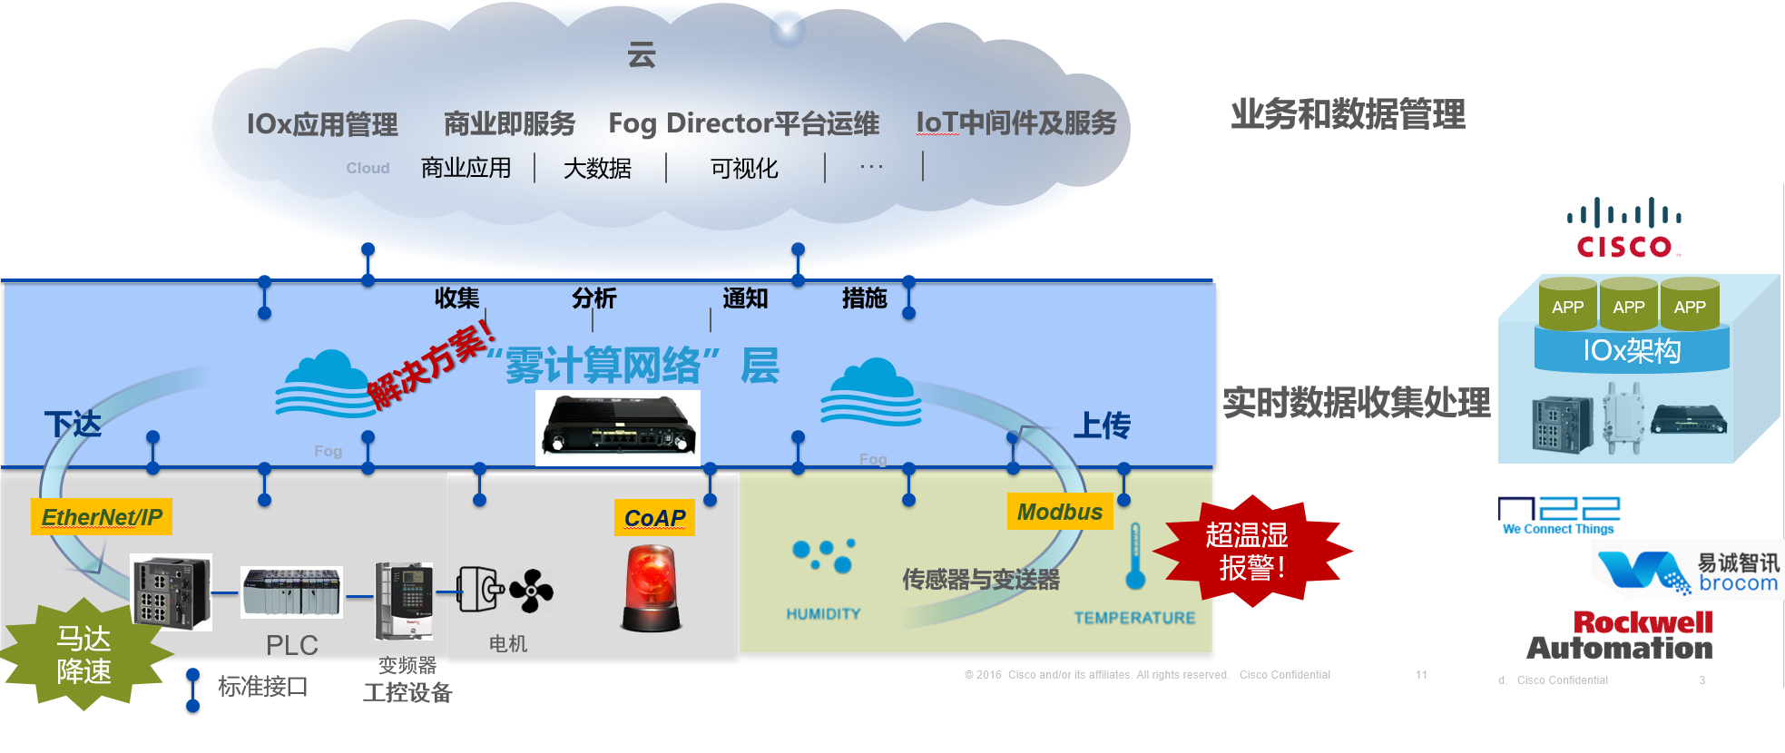

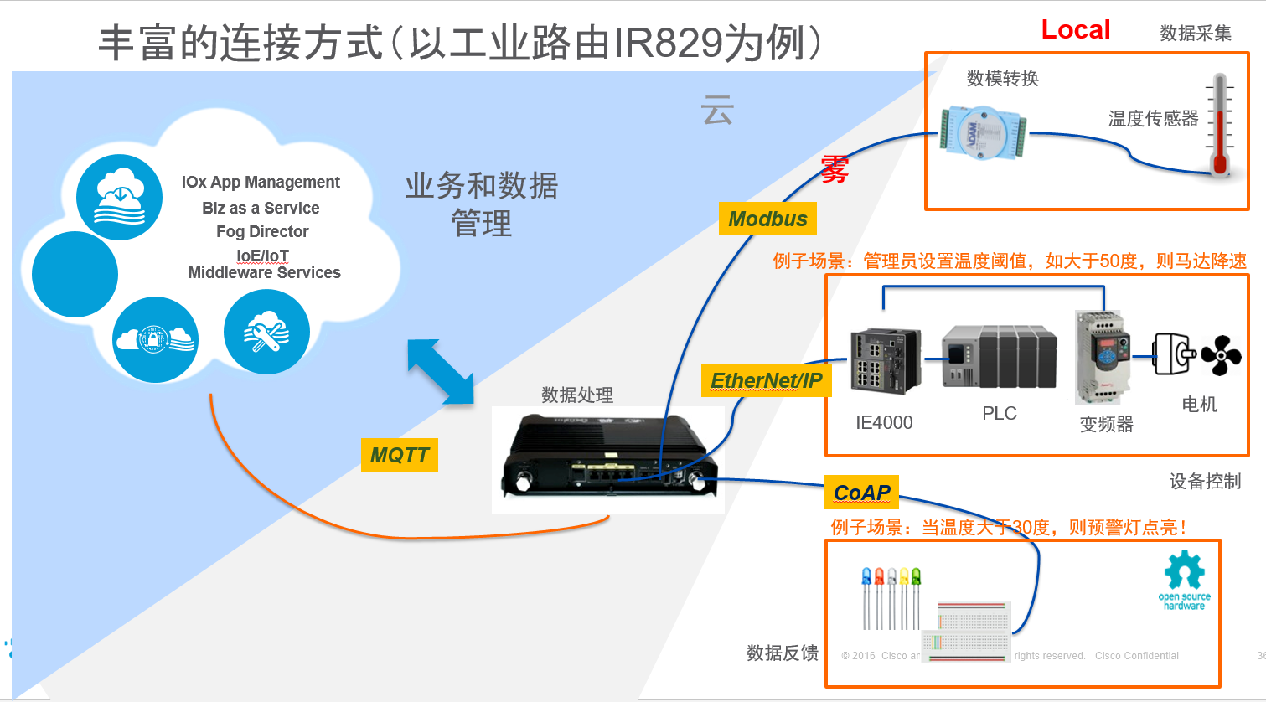s 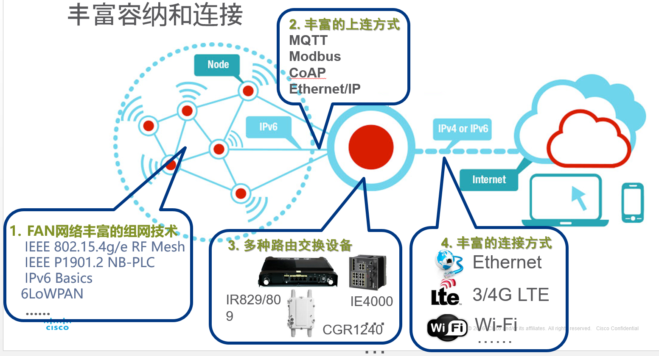

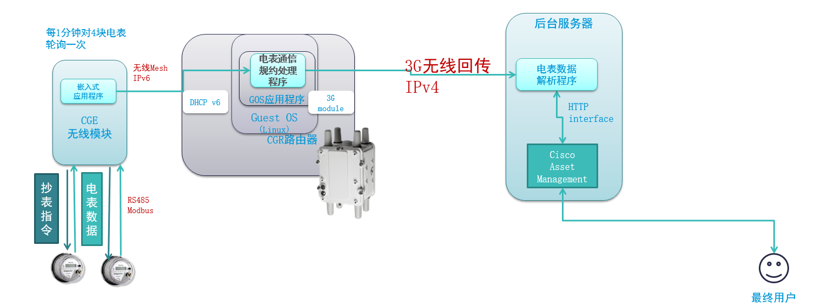

2.2 Ongoing projects (DS/ML)

### 2.2.0 Summary & Motivation:

Curiosity drove me to explore the field of data with the ambitions:

* Discover insights from data for solving real world problem,
* Bring innovation to market and customers, like how could we integrate the data & ML with the IT infrastructure to accelerate the delivery of the business value.

2 programs are based on genome, neuron image.- Harvard Medical School & Broad Institute.

1 program focus on ML/DS platform development, models interpretability- NEU, industrial company.

By keep learning interesting Genome knowledge/terms, best practice for variant discovery.

### 2.2.1 Neuron Imaging Research-Harvard RA

#### 2.2.1.0 Background:

* Quick learner and pick up the projects with curiosity and motivation:
* Applied ML/DS in more fields,
* Curious how to increase the efficiency in more innovative ways

#### 2.2.1.1 Goal:

* Improve significantly upon the state of the art of neuron segmentation from electron microscopy (EM) in accuracy and scalability-1st step.

#### 2.2.1.2 Action:

1. for picking up the project and learned from the big picture:

* Participated the entire pipeline for processing the neuron image manually on parallel computing 4 image volumes with 3 rounds in 3 weeks.
* Clean map and apply map; Anchored and Alignment; Stitching; Tracking the dendrite and identify the synapse, sheath of axon(Myelinated)

2. My thoughts with innovation:

* For training on multi-scale architecture with better performance, predicted 3D affinity graphs using a 3D U-NET architecture.

(Why 3D U-NET?

* U-NET is a network for volumetric segmentation that learns from images with sparse annotation.
* U-NETs has excellent performance on the segmentation of 2D image data, because of its multi-scale architecture.)
* To train the U-NET to minimize errors, used a structured loss based on MALIS(**Maximin affinity learning of image segmentation**)

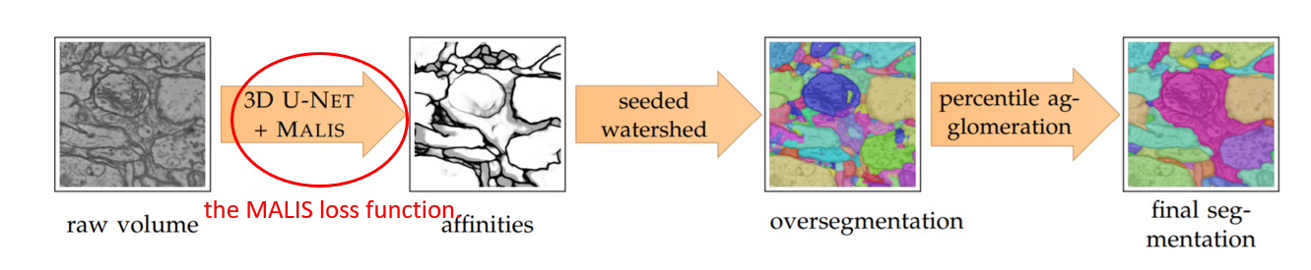

3. Challenges:

1. Sometime the images are in low spatial resolutions?

To handle this situation, predicted voxel affinities on edges between voxels instead of labeling voxels as foreground/background.

(It is impossible for low z resolution renders a foreground/background labeling of voxels.)

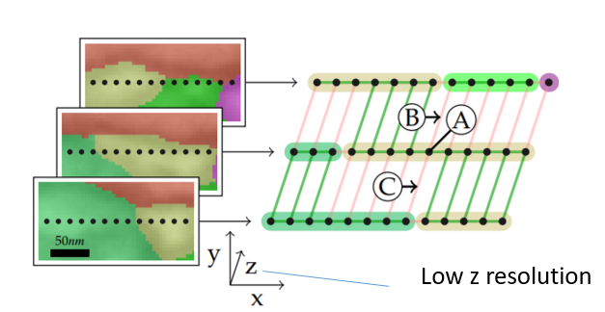

2. Avoid spurious gradients in early training stages?

A: Compute the MALIS loss in two passes:

* In the positive pass, constrained all predicted affinities between and outside of ground-truth regions to be 0,
* In the negative pass, constrain affinities inside regions to be 1.

#### 2.2.1.3 Result:

* Successfully optimized neuronimaging data processing with my motivation on data science and machine learning, to get rid of the noise, segmentation based on parallel computing environment.
* Now 8-10 hours to handle these: Without any background, 2 weeks

### 2.2.2 Project: Genome simulation & Dendrogram visualization + Broad Institute:

<https://nbviewer.jupyter.org/github/ziweifan177/Data_Science_Pilot/blob/master/NortheasternUniversity-AISkunk%20Club/Broad/code/FASTA/jupyter/genome_simulation_V1.4.7-VaryingLambda_FlexibleClusterMethod.ipynb>

#### 2.2.2.1 Goal:

* Massive datasets in genome and make the generations more visualized
* Further: Increase the efficiency of prediction on the mutation by more effective models.

#### 2.2.2.2 Action:

* Data process from huge .vcf files:
* Parsing, imputation into more structured datasets, genome postion, total coverage(DP), mapping quality(MQ)
* Simulate the mutation with my probability knowledge:
* Figure out the Dendrogram based on genome learning --visualized,
* (further) prediction and interpretability.

### 2.2.3 [Leadership] Project: Automatic platform for prediction and interpretability- with another industrial company/NEU, RA:

#### 2.2.3.0 Background & motivation:

1. Sometimes prediction is not well as expected, have no idea how to understand/optimize the model for a non-expert in DS/ML

2. Not efficient to handle the dataset manually and case by case

3. Client wants to understand the explanation on the individual observation visually.

#### 2.2.3.1 Responsibilities:

* !!!!!! Enhance the functionalities by interpretability for black box models:
  + (Suggested to the technical manager and my professor. They highly supported me with my reasonable thoughts—lead 5 members)

Interpretability Feature. Variable importance plot, PDP, Shaply plot LIME for global & individual data:

* + - LIME focuses on training local interpretable surrogate models to explain individual prediction:

(e.g.: if we **remove the item which has the 1 feature: value of 'area_worst'>1067.00**, what the probability of 'B' will turn to?)

* Lead & manage—Break down the problems + 5 members
  + Flexible data processing:
    - Any way? Upload flexible datasets to automate the entire data cycle—By platform
  + Understandable:
    - Trade-off: What makes these models accurate is literally what makes them difficult to understand for non-expert—‘Interpretability’
    - (Make the inaccurate model to be understandable for optimizing; Make the model make sense for individual observation)

#### 2.2.3.3 Challenge-Leading, management and technique:

* **[Management]** 
  + Issue:
    - They don’t have more background about interpretability and why we used that.
    - After conducted interpretability for general dataset, we combined with semantic analysis based on ‘review text’-word2vec algorithms and ML interpretability
* Action:
  + Made the architecture clear for bigger picture
  + Break down and figure them out step by step--Trello
* Result:
  + Aligned with the schedule perfectly--Trello
  + Everyone knows the structures well and contributed our thought
* **[Member motivation]** 
  + Issue:
    - Different situation (Schedule, Co-op/internship), held off their work for some reasons
  + Action:
    - make bonus: share some Co-op experience, documents/other interesting or funny stuff, share hobbies
    - Everyone will show the outcome during the meeting
    - Debug together
  + Result-happy ending:
    - Not boring and win-win
* Motivated for further thought: Images interpretability: +LIME.
  + e.g.: Bacterial image classification.

#### 2.2.3.4 Technical actions:

* Optimized the architecture of the code, by refactoring the code: data processing, scrubber, automodeler.
* Add more ML interpretability feature:
* Variable importance, Partial dependency plot, LIME, Sharply
* E.g: Breast Cancer Prediction + interpretability(VI, PDP, LIME):
  + <https://nbviewer.jupyter.org/github/ziweifan177/Data_Science_Pilot/blob/master/NortheasternUniversity-AISkunk%20Club/BreastCancer/Interpretability_Cases_1_BreastCancer_05302019.ipynb>
* Text analysis: Trained the model by involving NLP tokenizing, speech tagging, word2vec + sentiment analysis for prediction
* E.g.: PoC Testing: Amazon Review+Word2Vec:

<https://nbviewer.jupyter.org/github/nikbearbrown/H2O_Workshop/blob/master/AmazonReviews.ipynb>

* + Predict a new review is a good/bad score on some product and how to increase the prediction accuracy
  + Figure out which words variables will influence the prediction the most

E.g.: Review Classification-Yelp, Movietickets etc.

#### 2.2.3.5 Result:

* After exploring the interpretability, the model GBM performed better by 0.2 AUC increased,
* NLP: I used W2V and adding summary as the predictor,
* Demonstrated this project successfully to clients, converted it to a hands-on workshop as one of mentors on a DS bootcamp; Held by Cambridge innovation center this March. Positive feedback

#### *2.2.3.6: Knowledge:

Shaply:

1.

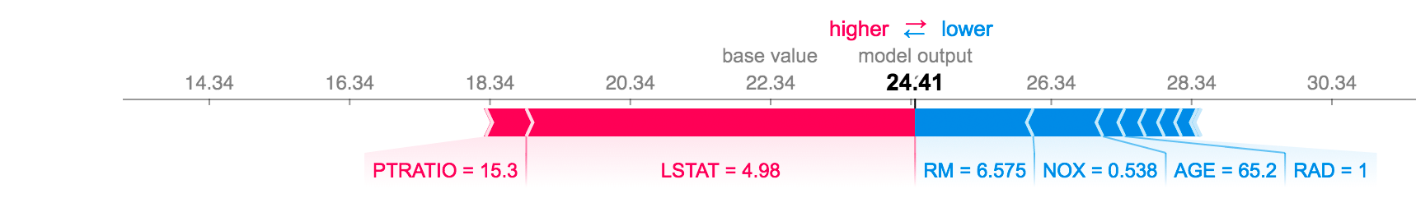

* Features pushing the prediction higher are shown in red,
* Features pushing the prediction lower are in blue

2. To understand how a single feature effects the output of the model

3. Show the effect of a single feature across the whole dataset

LIME:

- LIME focuses on training local interpretable surrogate models to explain individual prediction:

- An explanation is a local linear approximation of the model's behavior.

- While the model may be very complex globally, it is easier to approximate it around the vicinity of a particular instance.

- While treating the model as a black box, we perturb the instance we want to explain and learn a sparse linear model around it, as an explanation. but not necessarily globally.

(e.g.: if we **remove the item which has the 1 feature: value of 'area_worst'>1067.00**, what the probability of 'B' will turn to?)

### 2.2.4 NLP Project_Transportation + Twitter [Sentiment Analysis](https://algorithmia.com/algorithms/nlp/SentimentAnalysis?utm_source=blog&utm_medium=post&utm_campaign=nlp):

<https://nbviewer.jupyter.org/github/ziweifan177/Data_Science_Pilot/blob/master/%5BProjects%20and%20Testing%5D%20Data%20Science%20%26%20Machine%20Learning/Analysis%20%26%20Predict%20trip%20duration%20of%20taxi%20Based%20on%20Climate%20%26%20Geospatial%C2%A0data/FinalProject.ipynb>

#### 2.2.4.1 Goal:

* The google map sometimes reflect the worse or better traffic than I expected
* Wonder if the social media could help

#### 2.2.4.2 Action:

* Track customer satisfaction every 3 mins through sentiment analysis of Twitter's data: positive, negative or neutral
* Lib: Nltk, Tweepy(OAuthHandler, StreamListner), SnowNLP, textblob
* Steps/NLP Structure:

#### 2.2.4.3 Result:

* Increase the accuracy (80%): Bias
* Further:
* optimize by interpretability in NLP by more interpretable models: XRT/GBM
* Predict the traffic in some area by combining: sentiment + real hot area map

### 2.2.5 NLP Project 2: NLP+Amazon Review+Word2Vec:

<https://nbviewer.jupyter.org/github/nikbearbrown/H2O_Workshop/blob/master/AmazonReviews.ipynb>

#### 2.2.5.1 Goal:

* Predict a new review is a good/bad score on this product
* Figure out which words variables will influence the review score?
* Check how the predictions affected by the new factors added in (“summary”)
* Check how word2vec improve the AUC?
  + (Word2Vec model is used for learning vector representations of words called “word embedding”.)

#### 2.2.5.2 Action:

* 1 round: Train by Gradient Boosting estimator; AUC is 0.59; Interpret
* 2 rounds: NLP + Summary added in. Evalute:0.81
* Interpret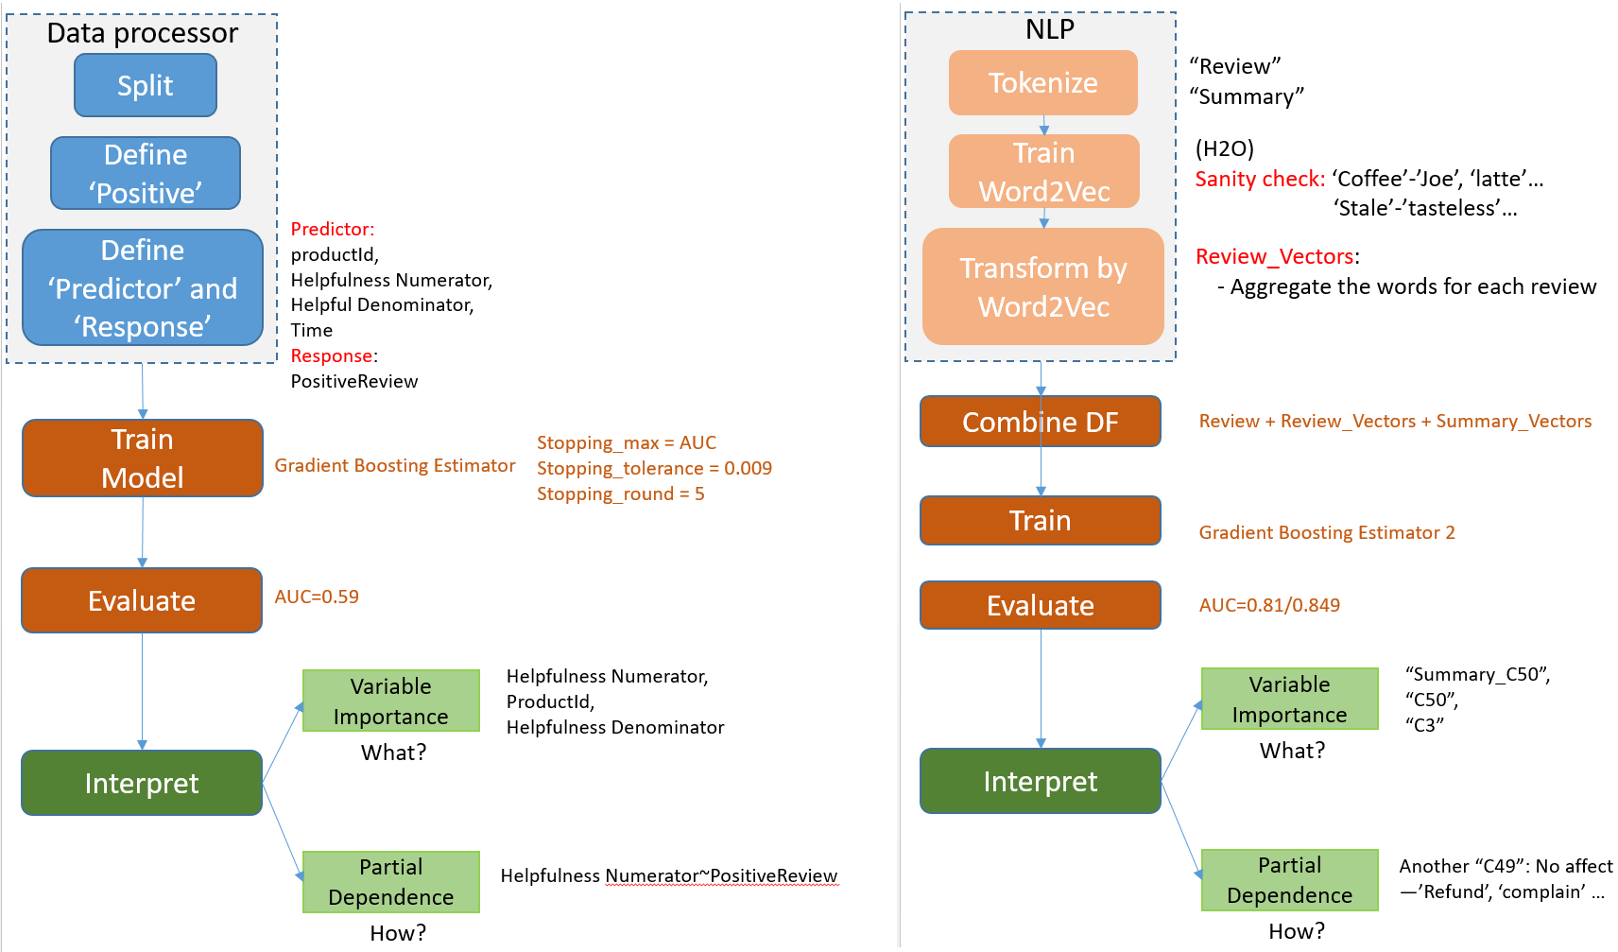

#### 2.2.5.3 Result

* After W2V and adding summary as the predictor, the model GBM performed better by 0.2 AUC increased.
* Presented and mentor this project on a data bootcamp held by Cambridge innovation center.

### 2.2.6 NLP Project-Yelp Review classification:

<https://nbviewer.jupyter.org/github/ziweifan177/Data_Science_Pilot/blob/master/%5BProjects%20and%20Testing%5D%20Data%20Science%20%26%20Machine%20Learning/Yelp_Review_Classification%28NLP%29/Classify_Yelp_Reviews.ipynb>

#### 2.2.6.1 Goal:

* Track the customersatisfactionregularly.
* Notice the restaurant when the satisfaction drop suddenly or significantly.

#### 2.2.6.2 Action:

* Classify Yelp Reviews into 1 star or 5 star categories based off the text content in the reviews.

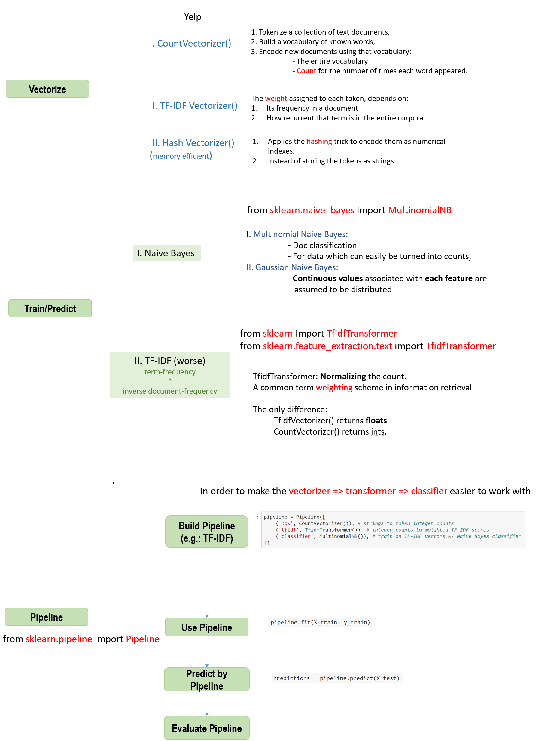

#### 2.2.6.3 Result:

* Figured out the TF-IDF performed worse than Vectorize.
* Learned TF-IDF

# Part 3. Other Behavior Questions:

* **Why you are a good candidate**?

- Like I said, I was in charge of … for couple years and have experience of data analytics DS/ML in industrial level.

I believe I could hit the ground running it

* **Tell me a time when you disagreed with your boss**
* **Tell me about a time with a specific example, where you thought you were right, but you were wrong.**
* **Tell me about a time when you were faced with a problem that had a number of possible solutions. (Search by ‘Challenges’)**
* **What was the problem and how did you determine the course of action?**
* **What was the outcome of that choice?**
* **When did you take a risk, make a mistake, or fail? (Search by ‘RISK’)**

**How did you respond, and how did you grow from that experience?**

* **Describe a time you took the lead on a project.**
* **What did you do when you needed to motivate a group of individuals or promote collaboration on a particular project?**
* **How have you leveraged data to develop a strategy? (Transportation/manufacturing, Best KPI and the margin contribution sales in that filed, stability/Secure/automation)**

# Part 4. Plan:

## 4.1 Short term:

Get ready to learn more machine learning certificates, like Amazon EMR, AWS Sagemaker.

Enhance my R skills to solve real problems

## 4.2 Long term goal:

**- Motivation, treat my career as the long-term rather than occasional one:**

- Enhance my understanding in entire lifecycle of the industrial environment to address DS/ML problem.

- Architect or expert in DS/ML:

- Specific problems, more interpretable models to balance the accuracy and interpretability

- Accelerate the delivery of business value

# Part 5. QA and Ending:

Thank you very much for the call, Appreciate interviewing me.

Pleased to have further talk if any opportunity.

???

Interested in the team and XXX product!

Q0. How could the team work to support the customer-based feedback? Lead some feature to improve?

Q1. Will the role provide any supportiveness to improve my contribution?

Q2. Customer’s Authorization & Privacy:

“Add an iPhone 11 pro into my Amazon cart!’ Can Alexa recognize the person by different voice or tone for authorization?

“Some violent news are not suitable for children.” If a child ask Alexa to do, can it identify it is a child’s tone?

Q3 [Test/optimization]. Is it 100% accurate? How did you identify or interpret the false reaction from Alexa?

Q4 [Roadmap]. When 100% accurate, is it possible to bring an industrial or business Alexa more than consumer level?

Q5 [Roadmap]. How can Alexa decide what mean by ‘Where is my car’?

Any other fields will be involved through Alexa & Echo, like automotive? Except for entertainment?

Q2. Customize for the disabilities, like deaf-mute?

* Define the wake-word by “Knock the tables 3 times” rather than speaking to wake up,
* Activate device by finger interaction with Alexa & mobile phone

Q2. New ideas on how to improve them: How can the team members know the feedback from customers? How long is the cycle to improve a feature?

Q2. Q2. Datasets, in-time data?

Q2. Will the role involve any excitement or constant change?

Q3. Knowledge in some specific fields? Professional management skills, biology, banking.

# Part 6. WHY company?

## 6.1 Why DataRobot?

* Innovation:
  + DataRobot is the first, automated machine learning platform, effectively address the steps of the modeling lifecycle.
* Fit my thought and previous experience:
  + PLATFORM: Change the way for clients to make decision by AI/ML, make it automated.
  + My previous: Only difference, cloud & IoT automation deployment and maintenance.
  + Purpose-driven environment

## 6.2 Why Accenture?

* a leading global professional services company,
* To help clients improve their performance
* Business sense to make an extra mile and explore the potential requirements.

## 6.3 Why Amazon Alexa?

**- Company culture perspective:** focused on the customer, take use of my leadership skills to contribute or innovate.

- **Alexa/Echo perspective Match my previous:**

- Build something new that will change daily lives, Passionate to solve the complex problems with creative thought

- The opportunity to define the features to Make the product perfect by a variety of techniques, machine learning, NLU

- It is a great fit for my prediction for the future trend: image and speech understanding in the next decade

# Part 7. Data position Interview

## 7.1 DS structure:

Familiarity with a variety of technical tools for the manipulation of datasets:

Pipeline/Structure:

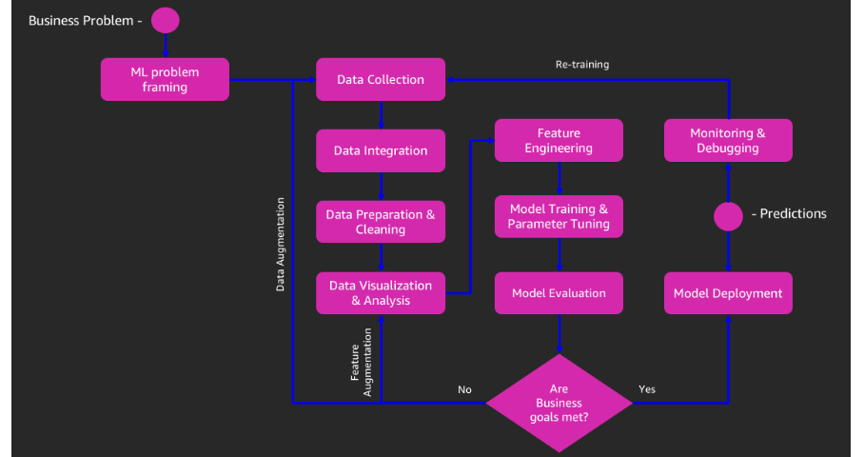

Visualization:

* matplotlib,
* seaborn: countplot, lmplot(Linear model), heatmap, clustermap
* pandas: pivot_table, plot()

Feature engineering:

* Imputation:
  + beginning with considering a possible default value of missing values in the column
  + medians:
  + Categorical Imputation:
    - maximum occurred value (Uniform Distribution)
    - ‘Other’ (Random selection)
* Outlier:
  + standard deviation:
  + percentiles: Dropping the outlier rows with Percentiles
  + Cap/Drop:
    - Cap: but capping can affect the distribution of the data
    - Drop: but dropping can affect the size of data
* Binning:
  + categorical and numerical data
  + Could prevent overfitting. Trade-off: performance VS overfitting
* Log transform:
* one-hot coding: get_dummies()
* binning: pd.cut()
* Grouping:
* Feature split:
* Scaling:
* Date:

Product:

gives you access to hundreds of the latest machine learning algorithms, with full transparency and control over the model building and deployment process.

use your domain expertise to find the best solution for your project and put it into production with just a few lines of code.

-------------------------------------------------------------------------------------------------------------------------------------

Asked Tech questions:

## 7.2 TECHQ_DS/ML

DataRobot (9.10,12):

### 7.2.1 Supervisor & Unsupervised?

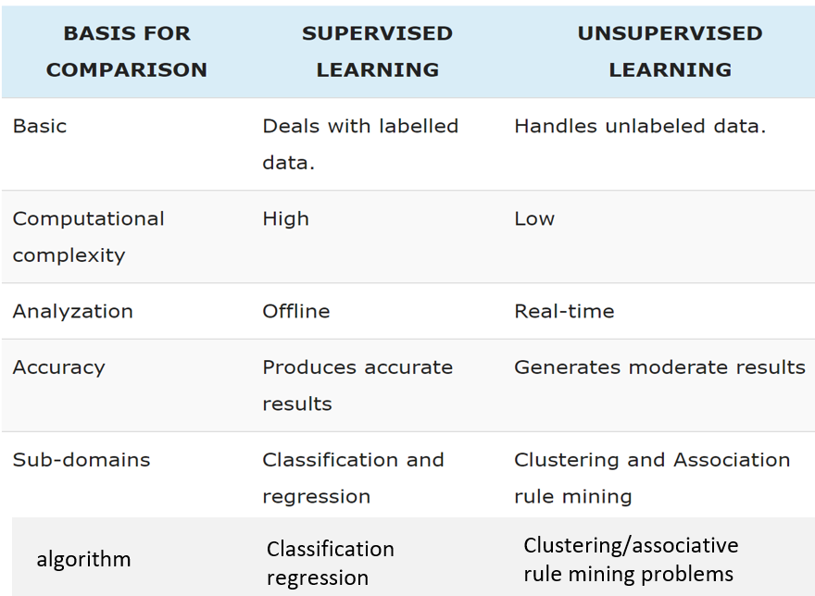

### 7.2.2 Interpretability-LIME

### 7.2.3 How to balance variance VS bias.

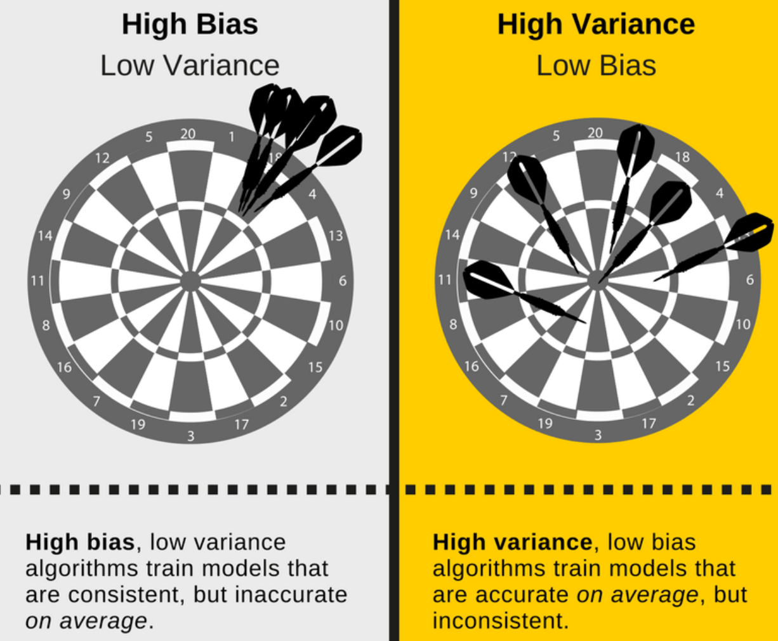

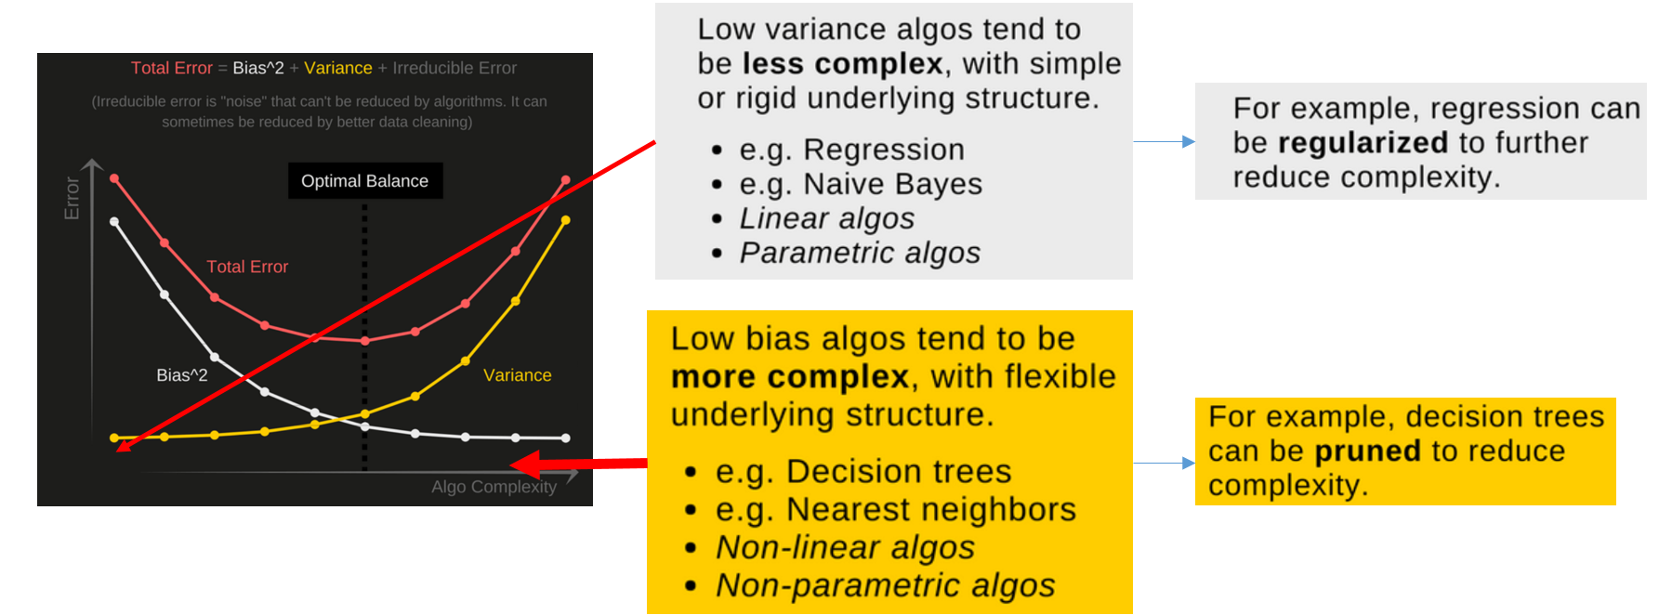

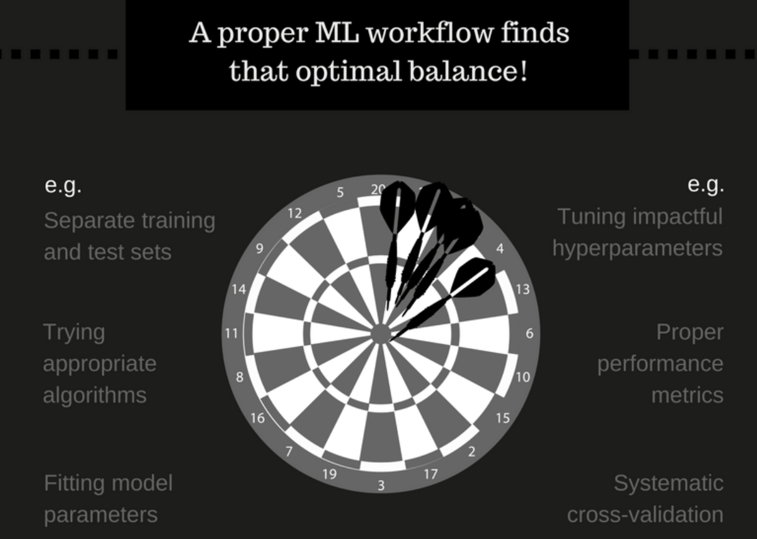

### 7.2.4 Explain random tree? What is the relationship within the sub-trees?

* + What?

(The[wisdom of the (random and diverse) crowd](http://phenomena.nationalgeographic.com/2013/01/31/the-real-wisdom-of-the-crowds/))

* + - To combine many decision trees into a single model.
    - Individually, predictions made by decision trees may not be accurate, but combined together, the predictions will be closer to the mark on average.
* How?

[Supervised machine learning model](https://medium.com/machine-learning-for-humans/supervised-learning-740383a2feab), a random forest learns to:

* + - map data (temperature today, historical average, etc.)
    - to outputs (max temperature tomorrow) in what is called the training (or fitting) phase of model building.
* Why?

Each decision tree in the forest considers 2 random points:

* a random subset of features when forming questions
* only has access to a random set of the training data points.

### 7.2.5 What is aggregation?

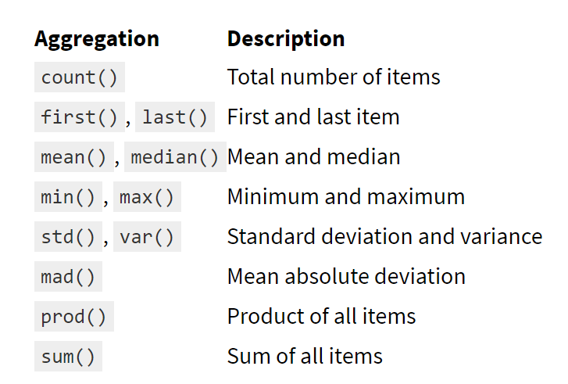

computing aggregations like sum(), mean(), median(), min(), and max()

describe() that computes several common aggregates for each column

### 7.2.6 How to process categorical data?

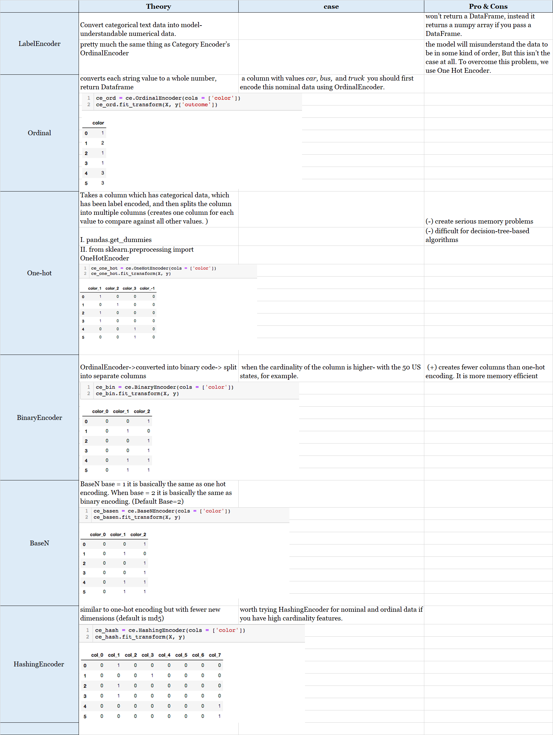

### 7.2.7 Which model you are most familiar with?

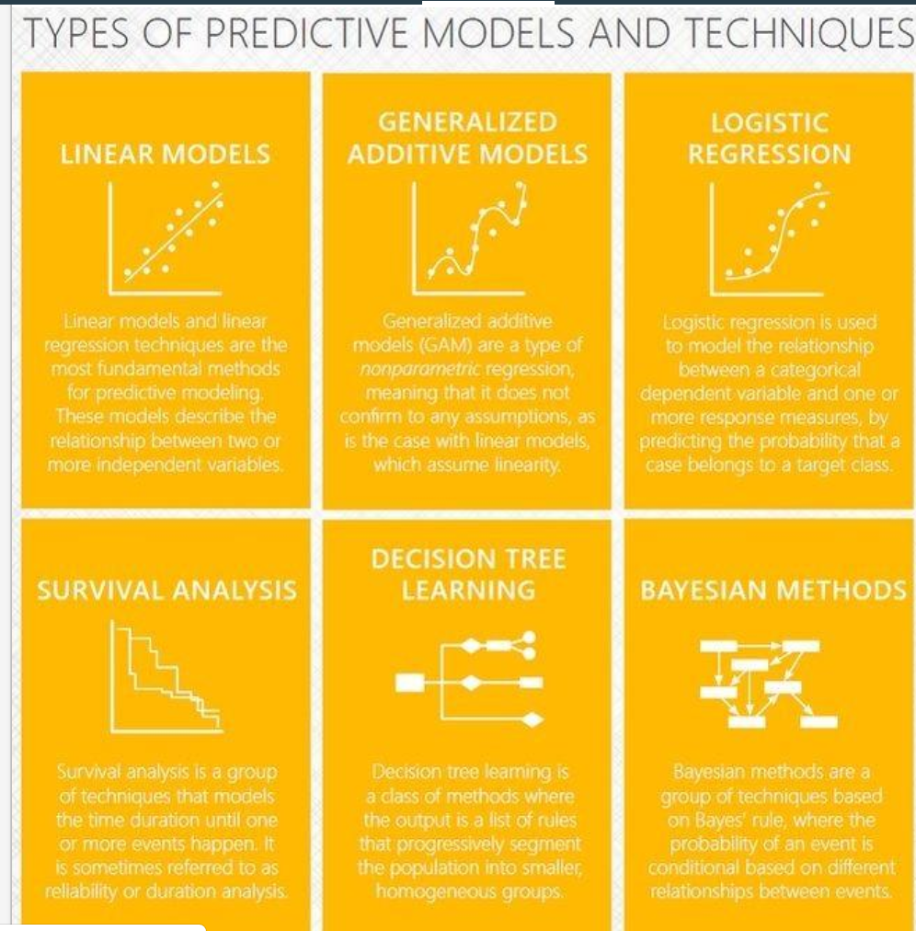

Linear: <https://machinelearningmastery.com/linear-regression-for-machine-learning/>

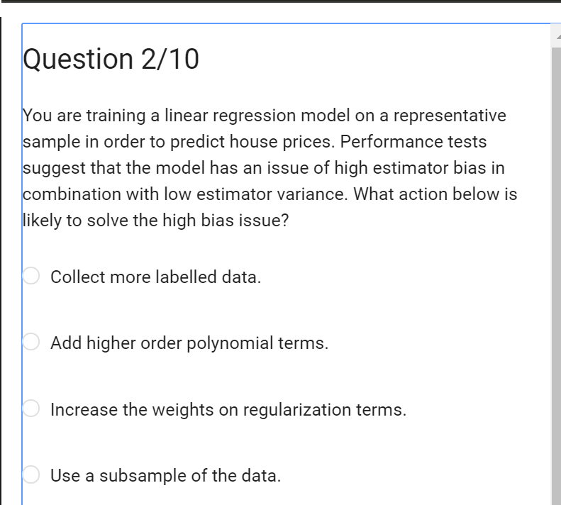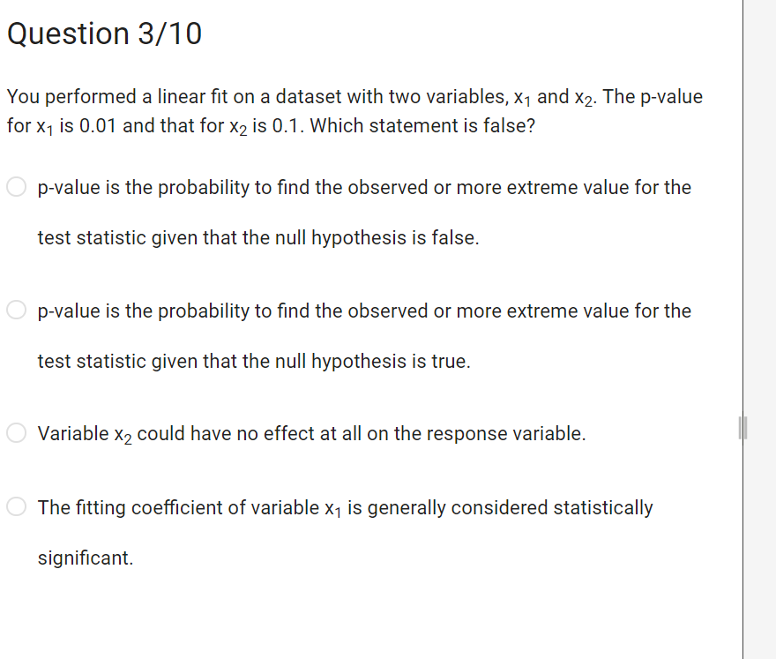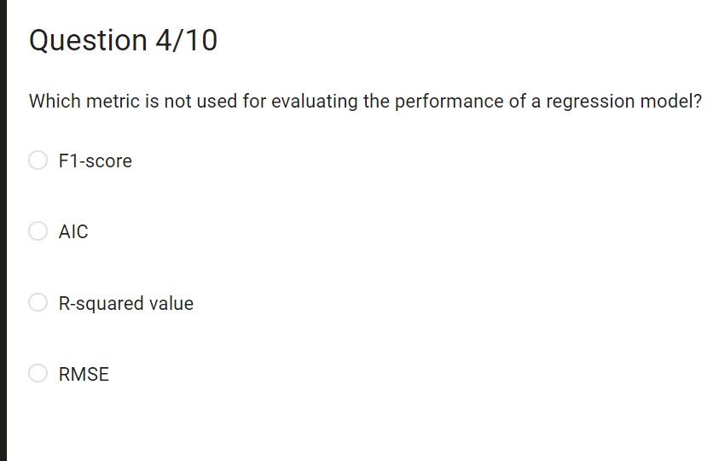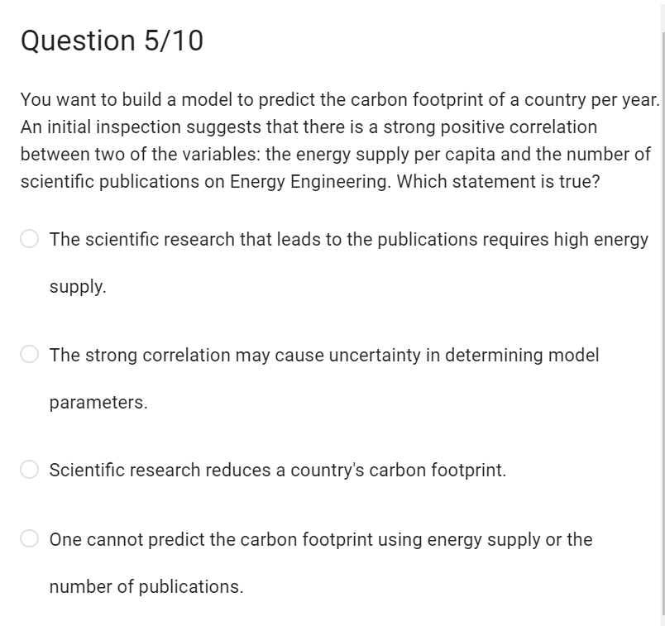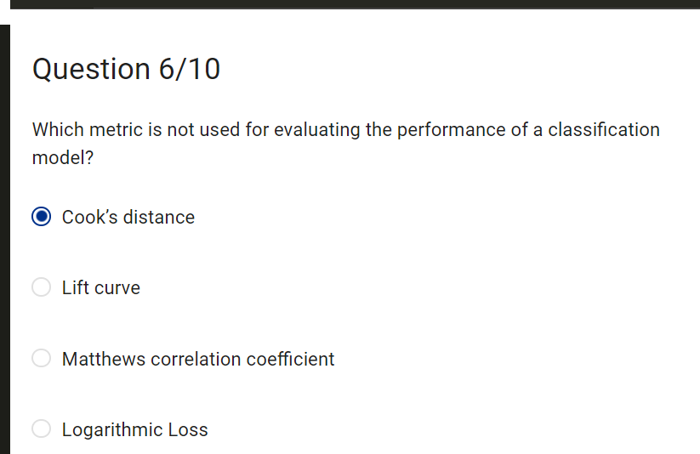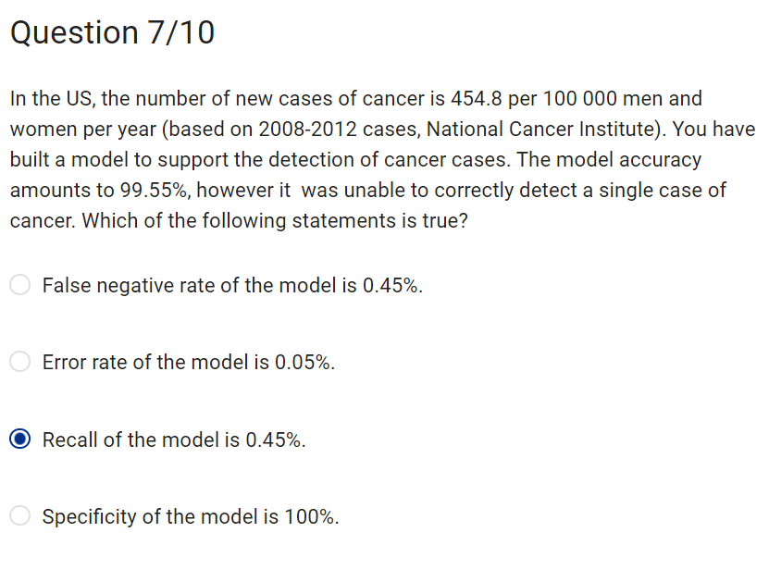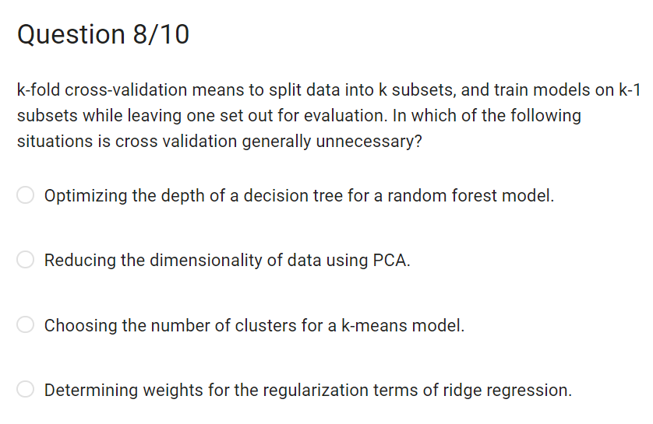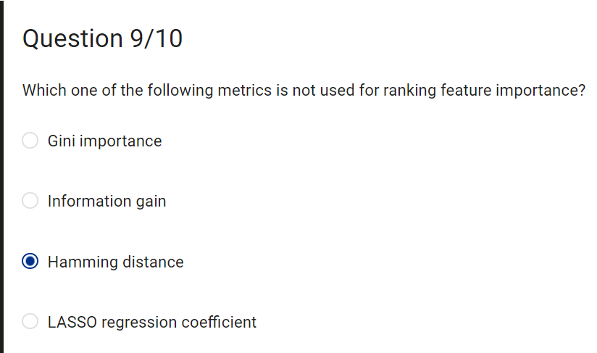

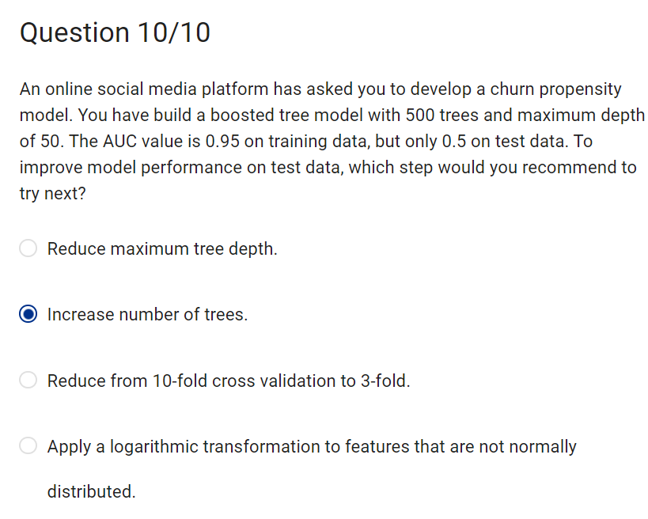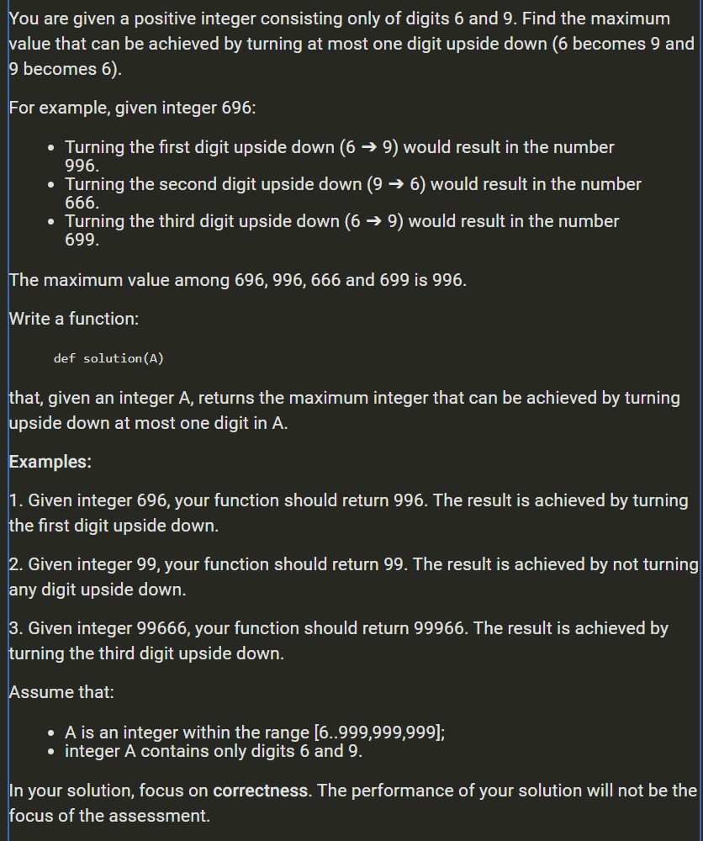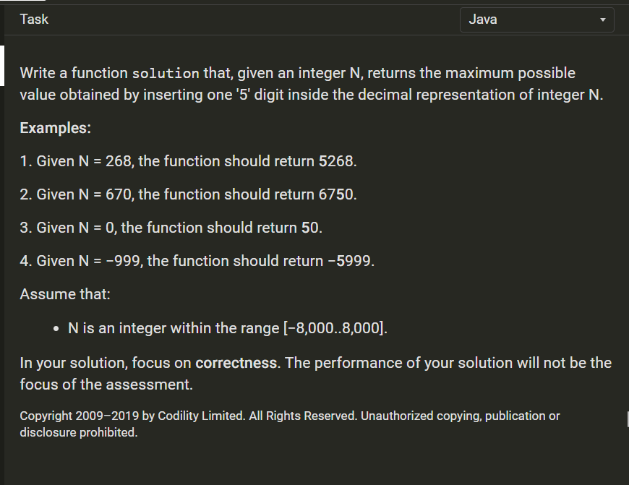

## 7.3 TECHQ_NLP:

### 7.3.1 NLP processing structure: (See above)

### 7.3.2 Word2Vec: (See above)

- Word2Vec model is used for learning vector representations of words called “word embedding”.)

### 7.3.3 Twitter real-time streaming:

<https://nbviewer.jupyter.org/github/ziweifan177/Data_Science_Pilot/blob/master/%5BProjects%20and%20Testing%5D%20Data%20Science%20%26%20Machine%20Learning/Analysis%20%26%20Predict%20trip%20duration%20of%20taxi%20Based%20on%20Climate%20%26%20Geospatial%C2%A0data/FinalProject.ipynb>

<http://mashable.com/2011/11/08/natural-language-processing-social-media/#VbWC8PySNqqy>

### 7.3.4 RNN:

Why RNN not CNN?

- RNN have this capability (you can learn the dependency by BPTT i.e., Back propagation through time) RNN seems to perform better in those NLP tasks and that is why you basically use RNN.

- CNN will not learn dependency.

- What RNN?

- RNNs combine the input vector with their state vector with a fixed (but learned) function to produce a new state vector. They are networks with loops in them,

- Allows information to be passed from one step of the network to the next

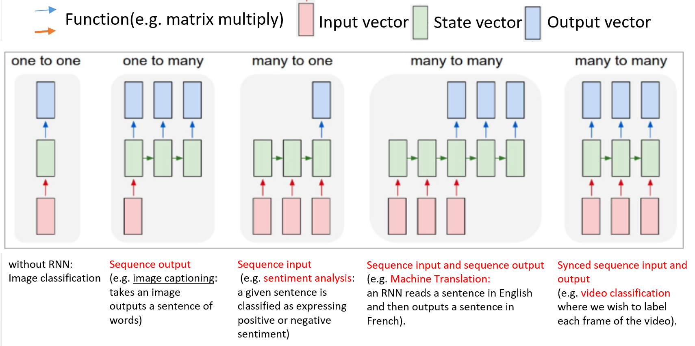

### 7.3.5. Other NLP interview questions:

#### 7.3.5.1 LSTM, GRU:

overperform than traditional RNN: LSTM, GRU give you more freedom in choosing and making the model learn on what to memorize, what to leave, what to add.

LSTM (Long Short Term Memory):

- More complicated than RNN. More gates: forget or not

- Could be: keep, erase, capture, release info by the close/open the gate.

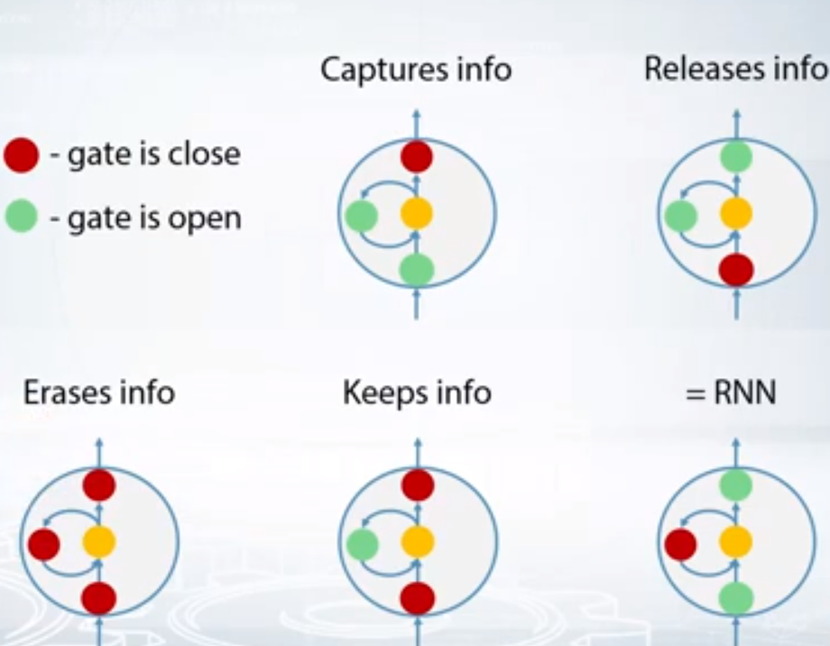

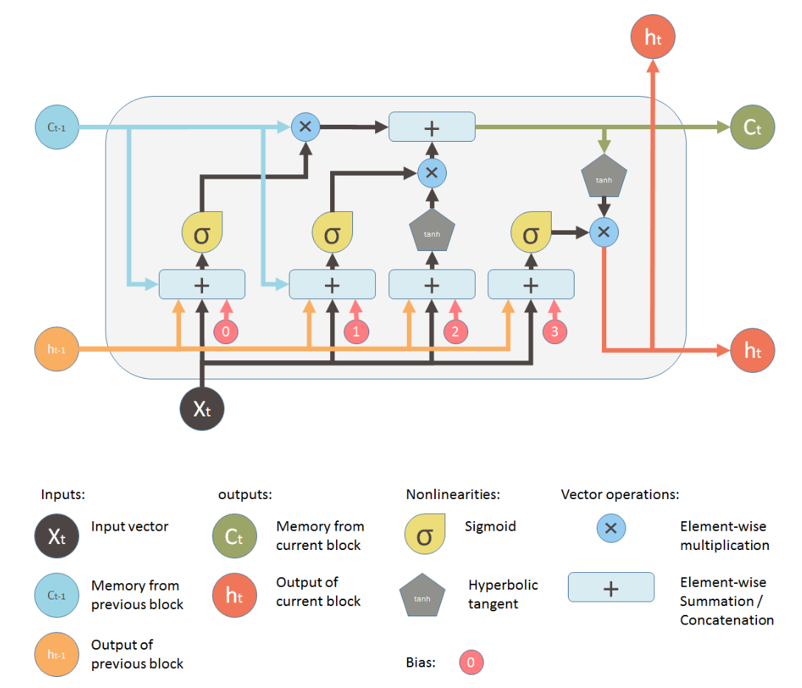

GRU (Gated Recurrent Unit):

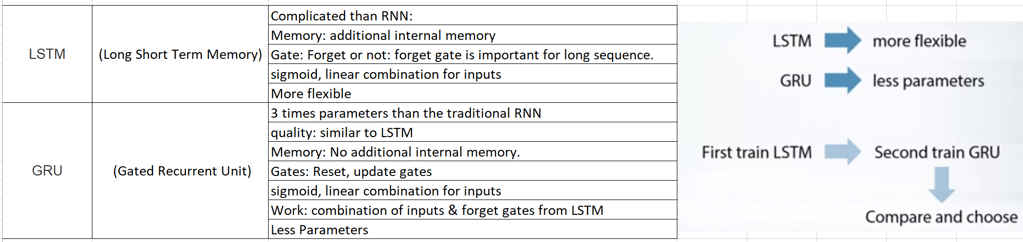

#### 7.3.5.2 Other topic-SyntaxNet:

A. [Google that uses Point-of-Speech tagging](https://research.googleblog.com/2016/05/announcing-syntaxnet-worlds-most.html): SyntaxNet: <https://ai.googleblog.com/2016/05/announcing-syntaxnet-worlds-most.html>

B. Another

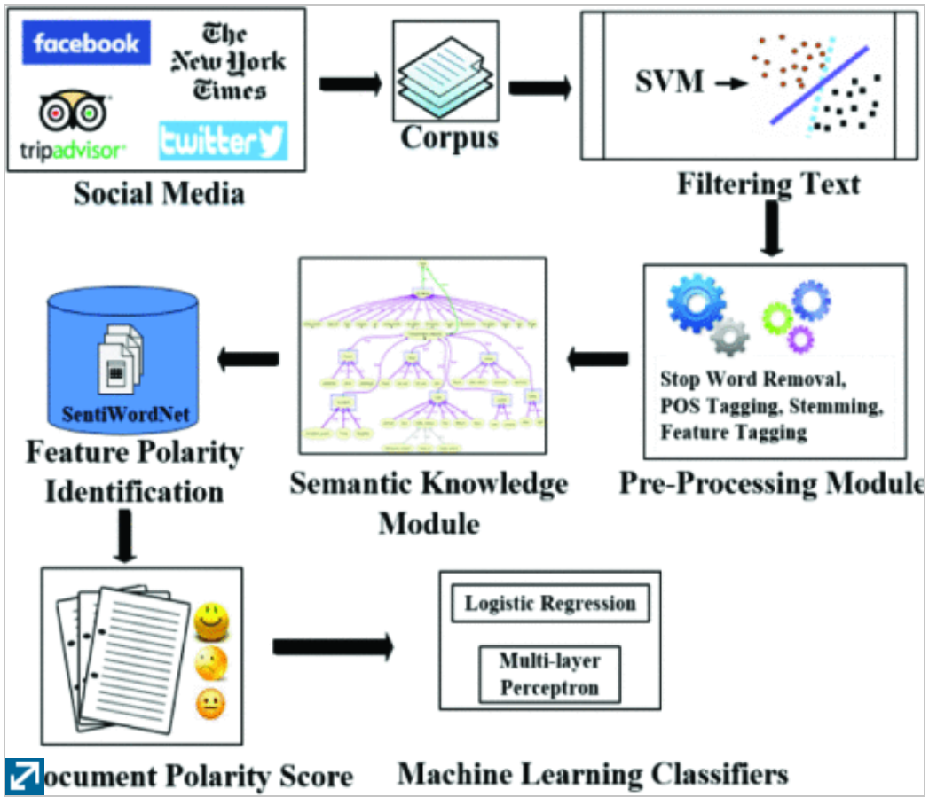

## 7.4 TECHQ_Architecture, Pattern Design:

### 7.4.1. Design pattern:

#### 7.4.1.1 Encapsulation:

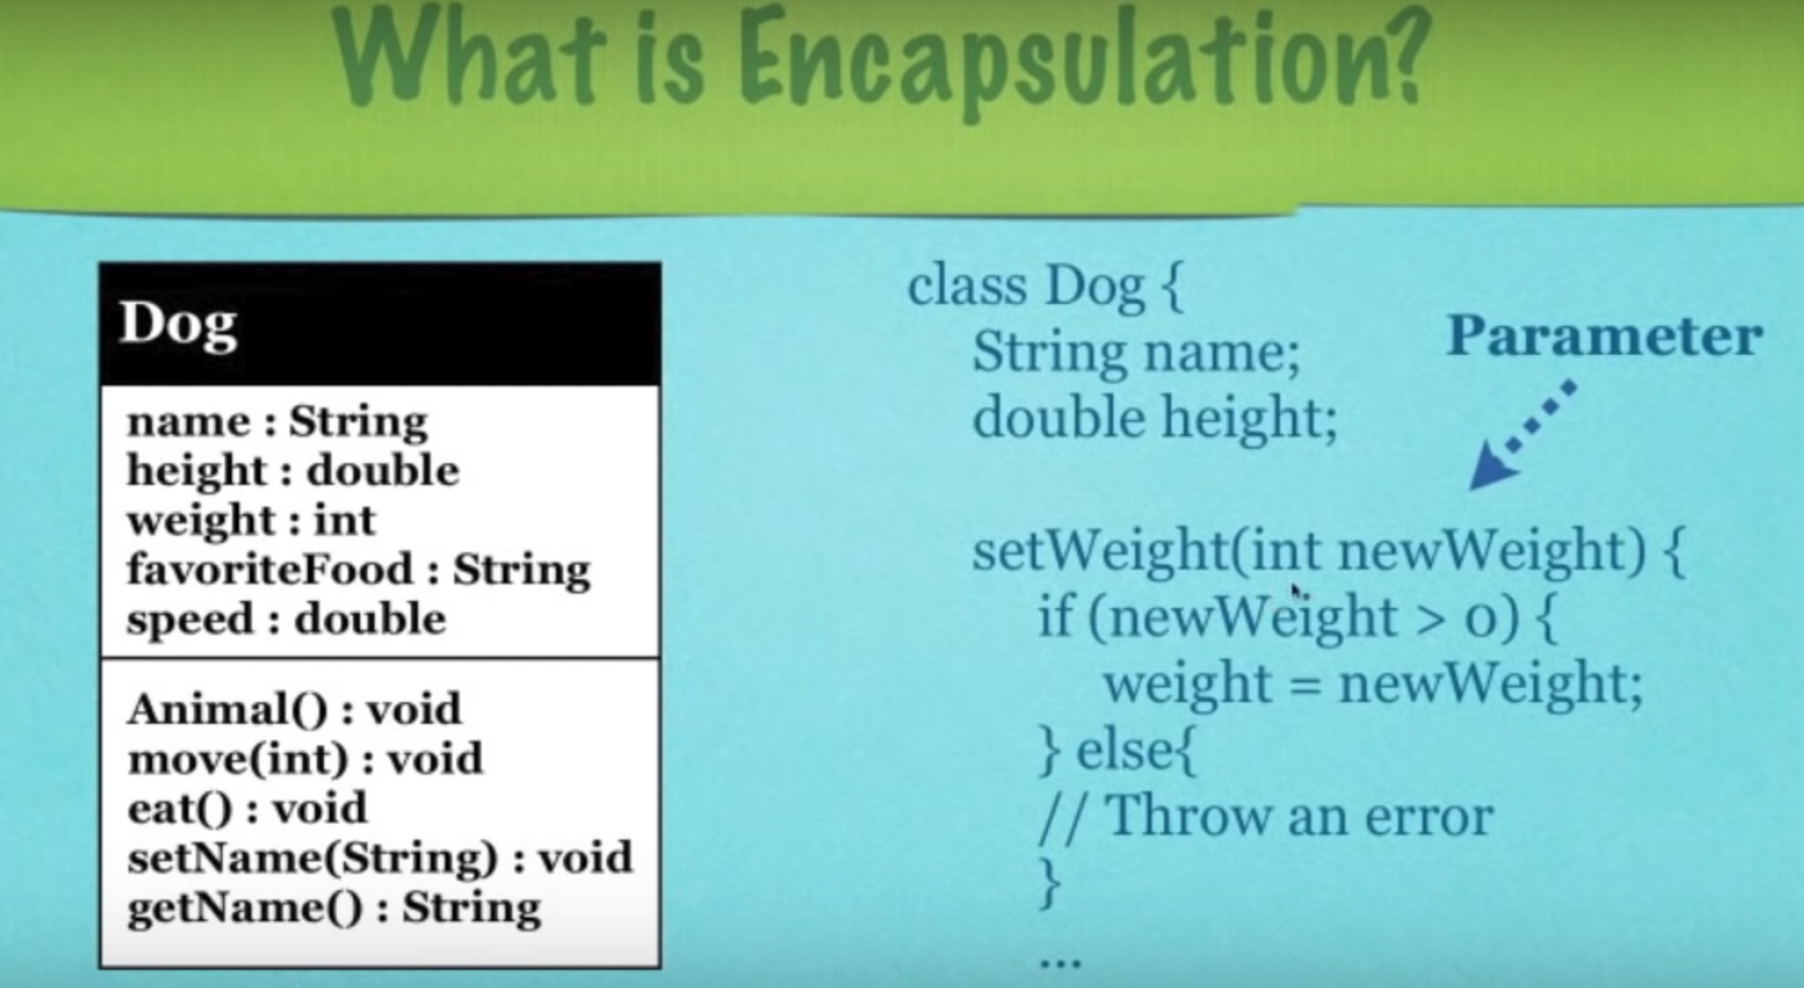

#### 7.4.1.2 Factory pattern:

1. What?

Define an interface for creating an object, but defer object instantiation to run time.

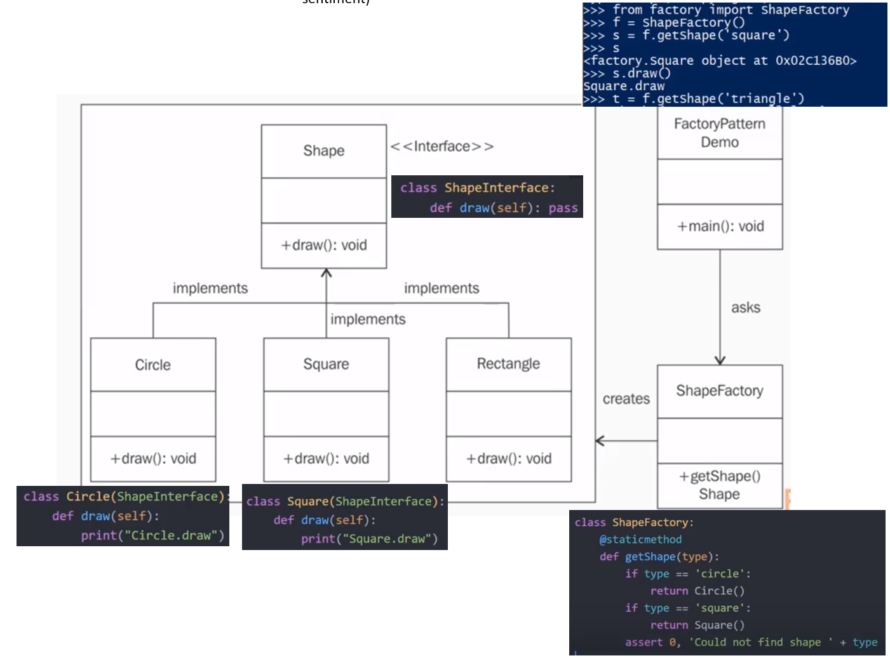

Sequence diagram:

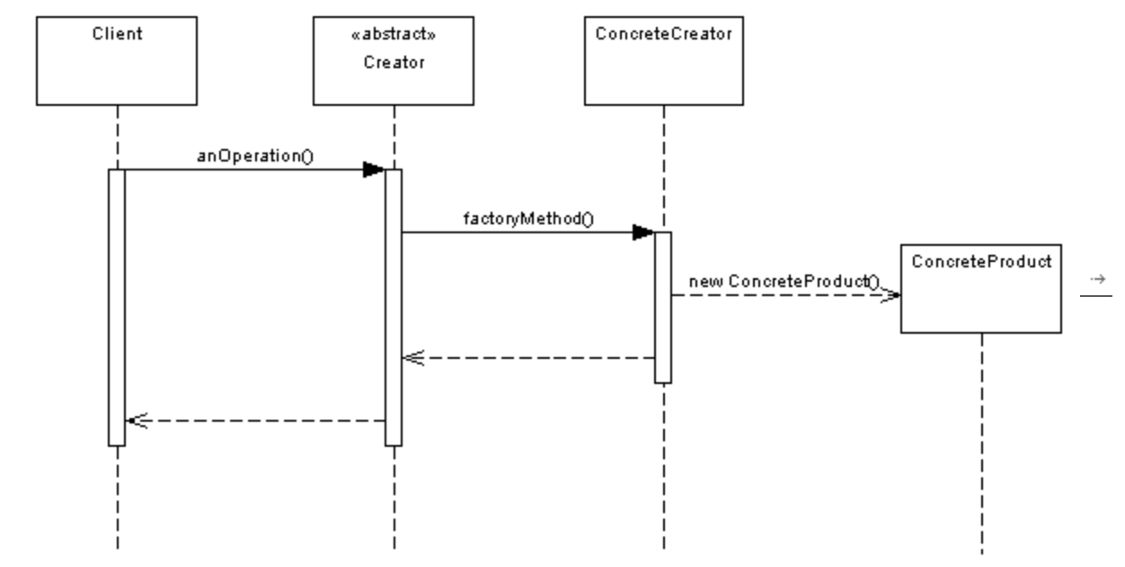

2. When & Why use Factory pattern?

Usage of Factory design pattern:

* When a class doesn't know what sub-classes will be required to create
* When a class wants that its sub-classes specify the objects to be created.
* When the parent classes choose the creation of objects to its sub-classes.

#### 7.4.1.3 MVC(Model View Controller):

1. What is MVC?

* MVC divides the related program logic into interconnected elements.
* Separate internal representations of data from the ways it is presented to /accepted from the user.

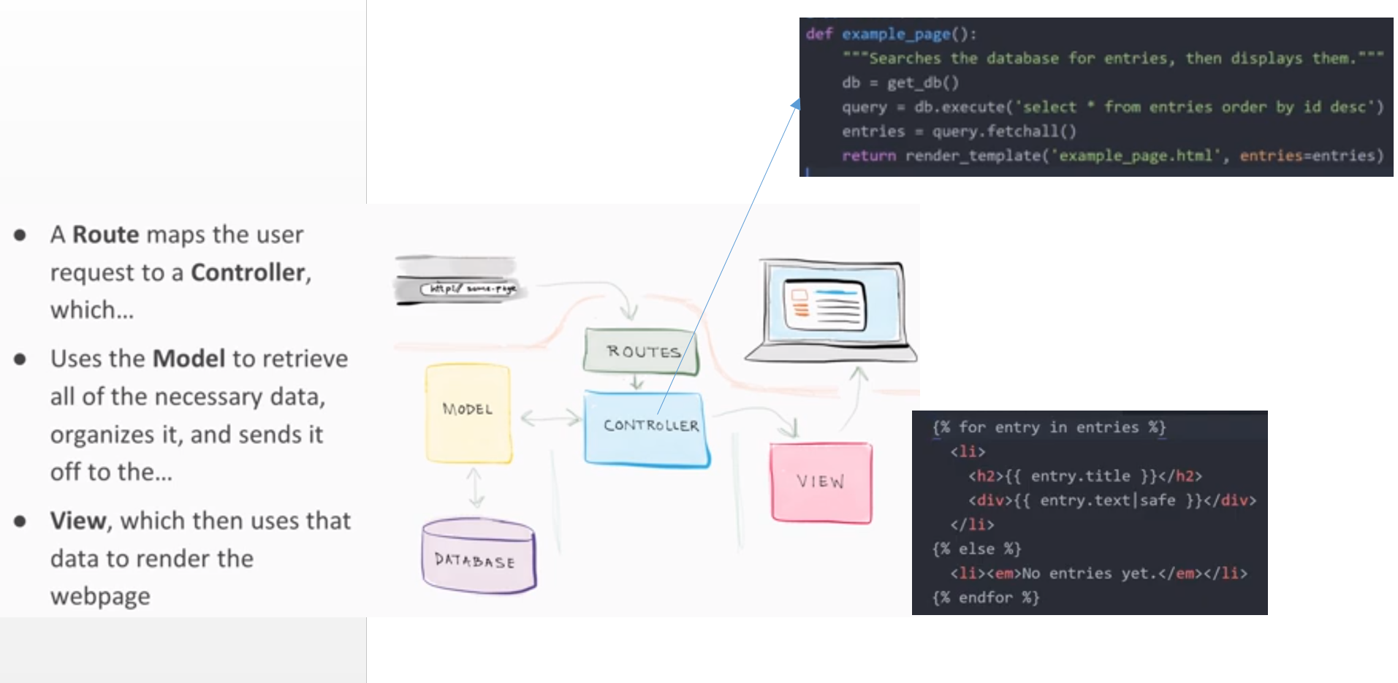

2. Why MVC?

- Decouples these major components allowing for [code reuse](https://en.wikipedia.org/wiki/Code_reuse)

- Parallel development

#### 7.4.1.4 Command Pattern:

1. What is Command Pattern?

Decouple the object that invokes the operation from the one that knows how to perform it.

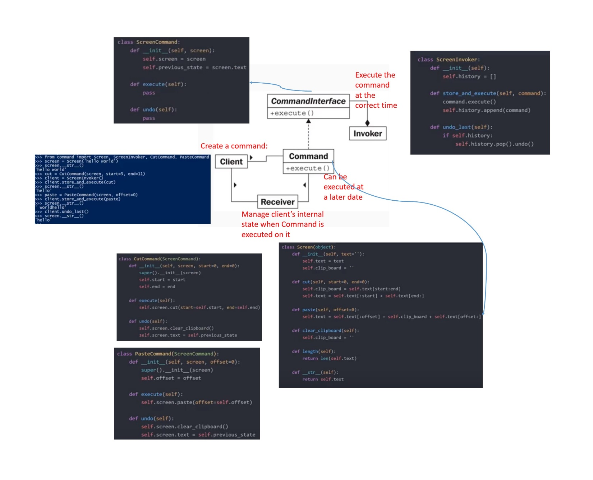

#### 7.4.1.5 Observer Pattern:

1. What?

Define a 1:many dependency, between objects so that when 1 object changed state, all its dependencies are notified & updated automatically.

2. When & Why Observer Pattern?

* It is mainly used to implement distributed [event handling](https://en.wikipedia.org/wiki/Event_handling) systems

3. Pros & Cons:

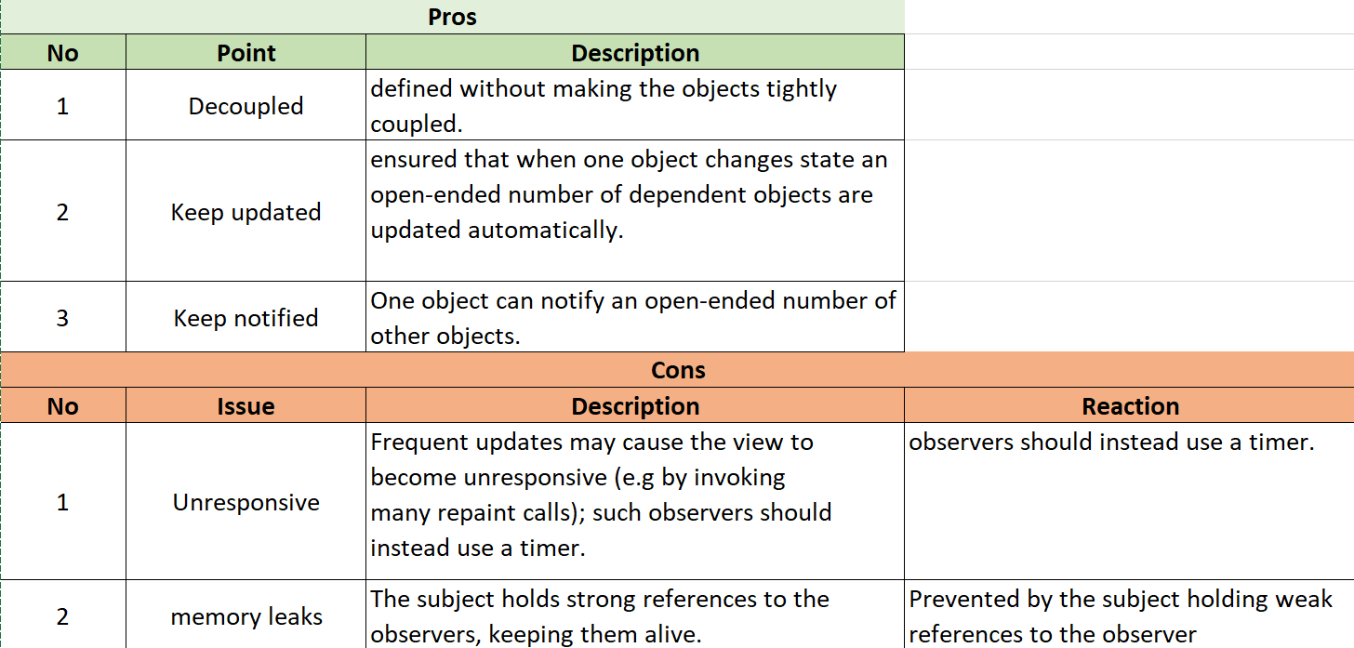

#### 7.4.1.6 Singleton Pattern:

1. What?

* Only 1 instance exists at any given time.
* Singleton encapsulates a shared resource within a single unique class instance.
* _init()_ still works but will be called EVERY TIME ‘class Singleton()’ is called.

2. How?

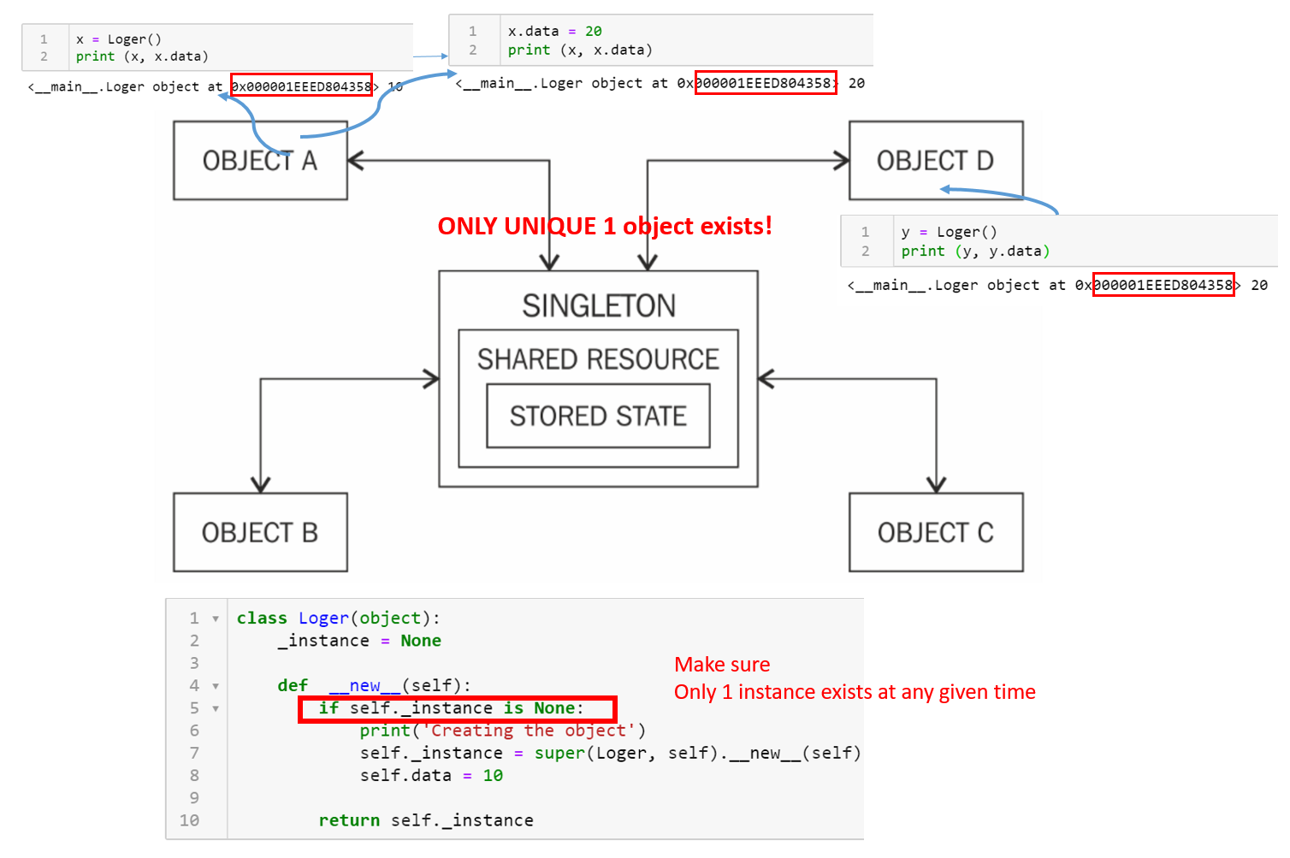

3. Pros and Cons:

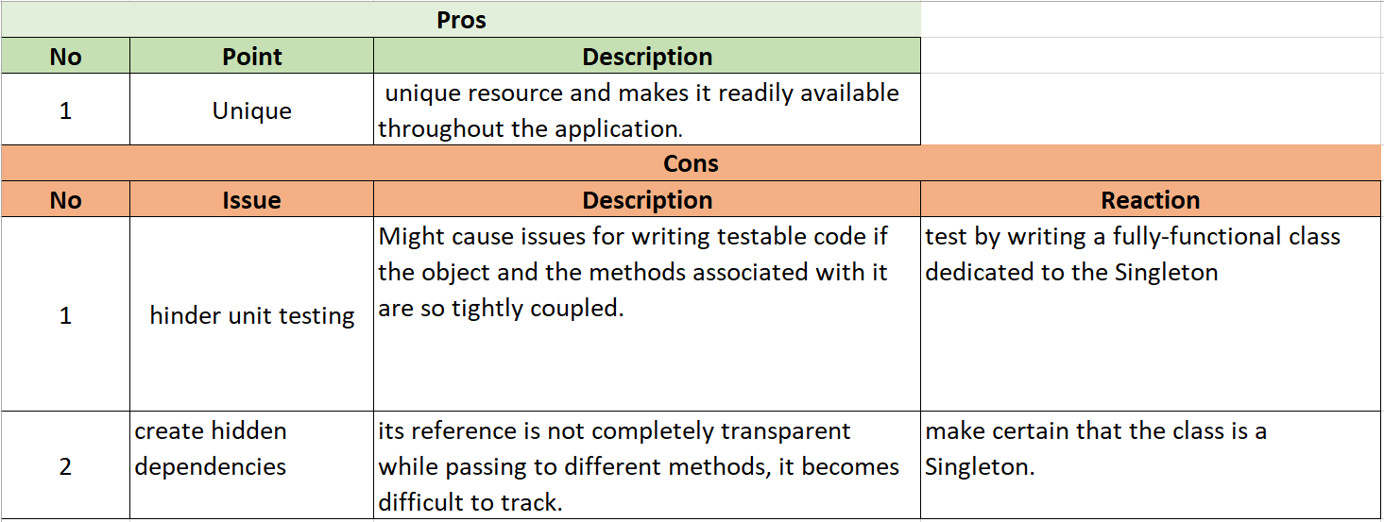

### 7.4.2. Architecture:

#### 7.4.2.1 Latency issues:

* **How to Improve Application Performance and Reduce Latency**

A: The hardest part: identifying the sources of latency in your application and subsequently eliminating them:

* Network I/O:
  + The closer your client is to the server, the lower the network latency.
  + Eliminate network hops: clustered queuing and storage systems, data can be horizontally scaled across many host machines
  + In the cloud, keep all processing in one availability zone.
* Disk I/O:
  + Accessing memory can be upwards of 10,000x faster than a single disk seek. Instead use write-through caches or in-memory databases
  + Use fast storage systems, such as SSDs
  + reduce the load on the master database
* OS:
  + Run your application on dedicated hardware
  + Be careful when use virtualization:
    - hypervisors impose a layer of code between your application and the operating system
* Code:
  + Inefficient algorithms : unnecessary loops or nested expensive operations in code
  + Multithreaded locks: Use design patterns that avoid locking, especially when writing server-side applications.
  + Limiting the queue depths typically reduce wait time
  + use a read replica + move non-critical [GET services](https://en.wikipedia.org/wiki/Hypertext_Transfer_Protocol#Authentication_realms) to read replica
    - e.g: read replica to Load comments associated with a blog—as it can handle some delay.

### 7.4.3. How to increase scalability?

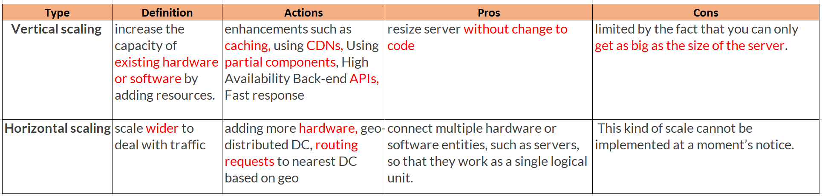

**Step 1:** Reduce server load

* Run regular workload on premises + Cloud for workload for scalability
* e.g.: By moving image and video to some 3rd-party content delivery network (CDN).

(which is highly scalable + built-in security to verify origin access identity+handle any DDoS attacks.) which provides efficient caching.

**Step 2: Reduce read load**

* **By adding more read replicas**
  + Most mirror technologies do asynchronous replication.
  + Plan and design your application accordingly.
* By distributed caching:

Step 3: About design pattern:

* Job-observer pattern by setting up Auto Scaling to automatically increase or decrease the number of batch servers

About data:

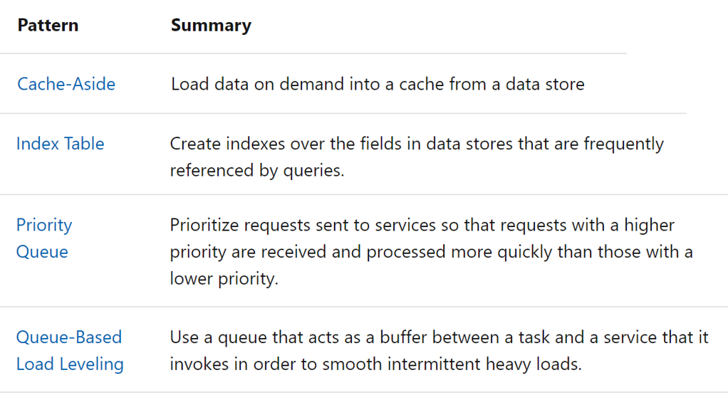

Step 4: **Scale your server.**

* Using horizontal scaling.
* Or creating a multisite architecture

e.g.:  Tech news website for digging out more:

* Where are images and videos stored?
* How many read/write requests are received per second? Per minute?
* What is the level of security required?
* Are these synchronous or asynchronous requests?
* How is the website handling sessions?
  + What are your loading balancing considerations (scaling, caching, session maintenance, etc.)?

### 7.4.4. How to increase reliability?

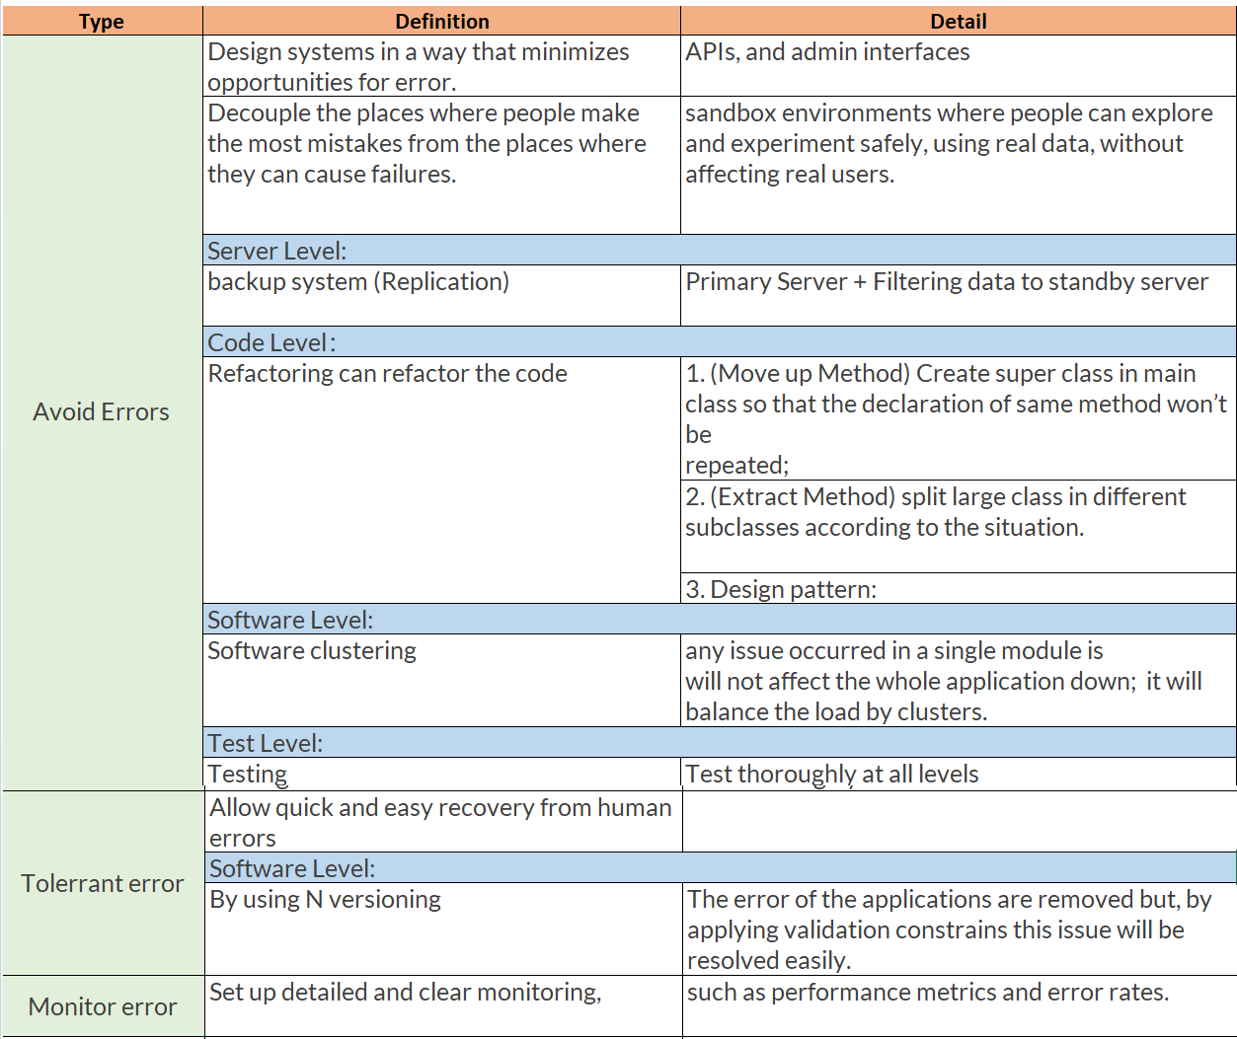

### 7.4.5. Full software develop lifecycle:

<https://melsatar.blog/2012/03/15/software-development-life-cycle-models-and-methodologies/>

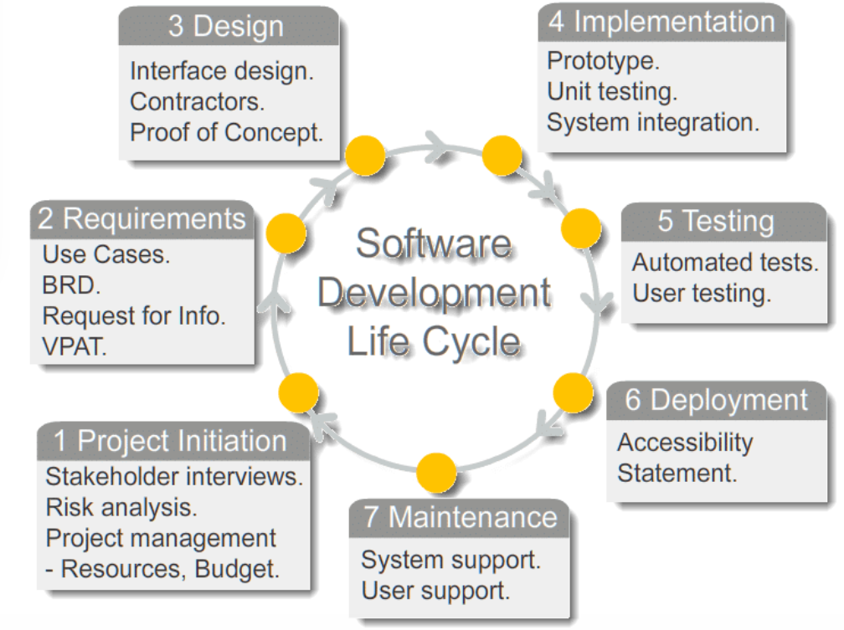

BRD:  Business Requirement Document

### - Code review:

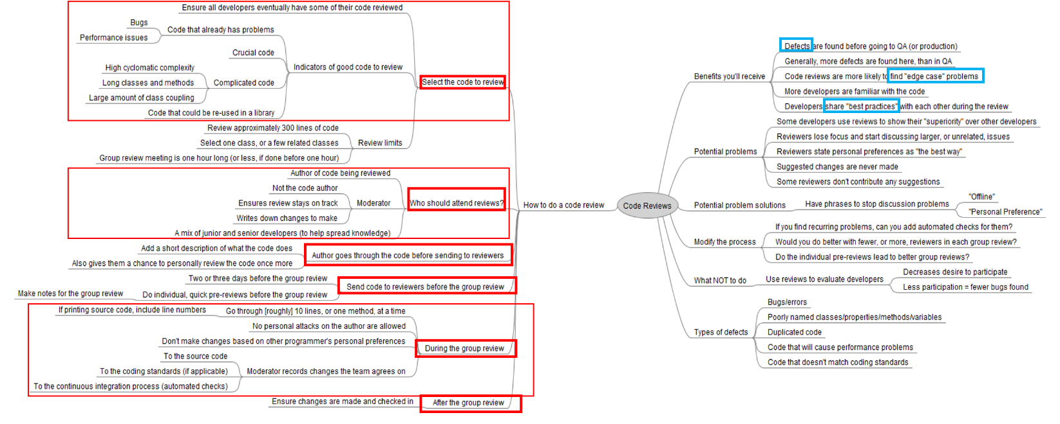

### - Source control management:

* work simultaneously, apply changes on any part of the source codes, perform parallel

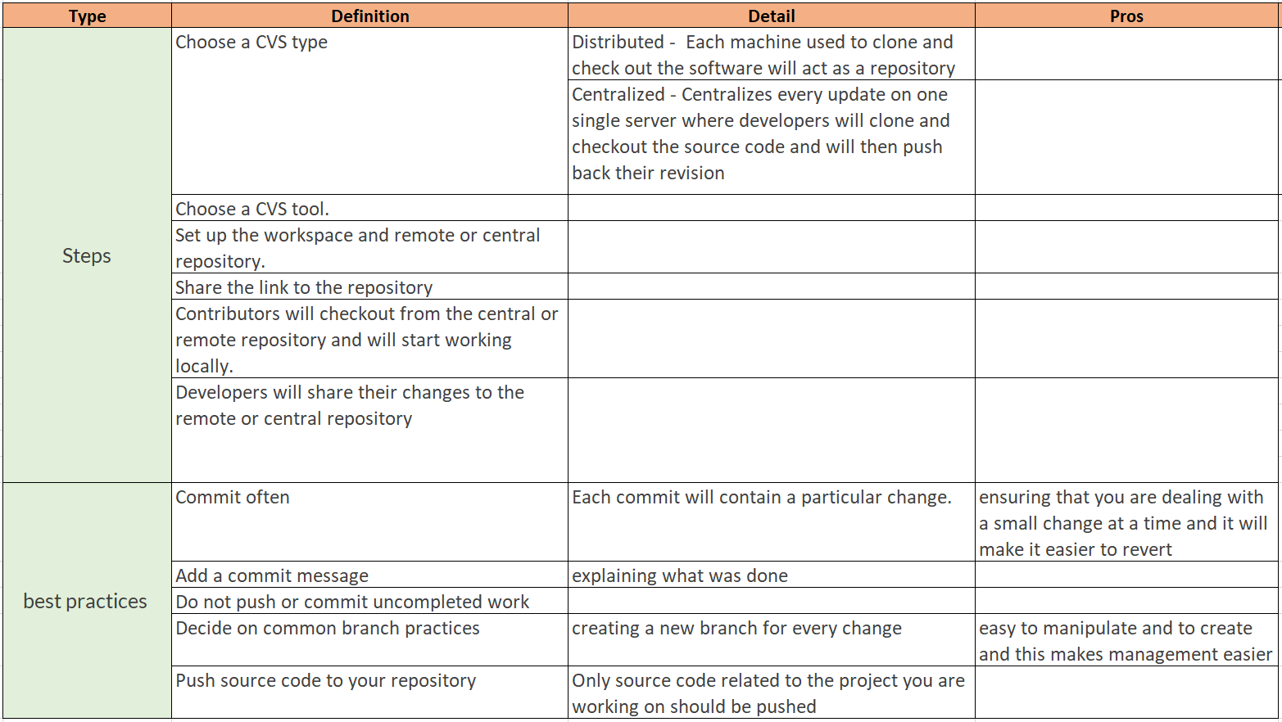

### - Building process:

### 7.4.6. service-oriented architectures (SOA):

### 

### 7.4.7. Map-reduce:

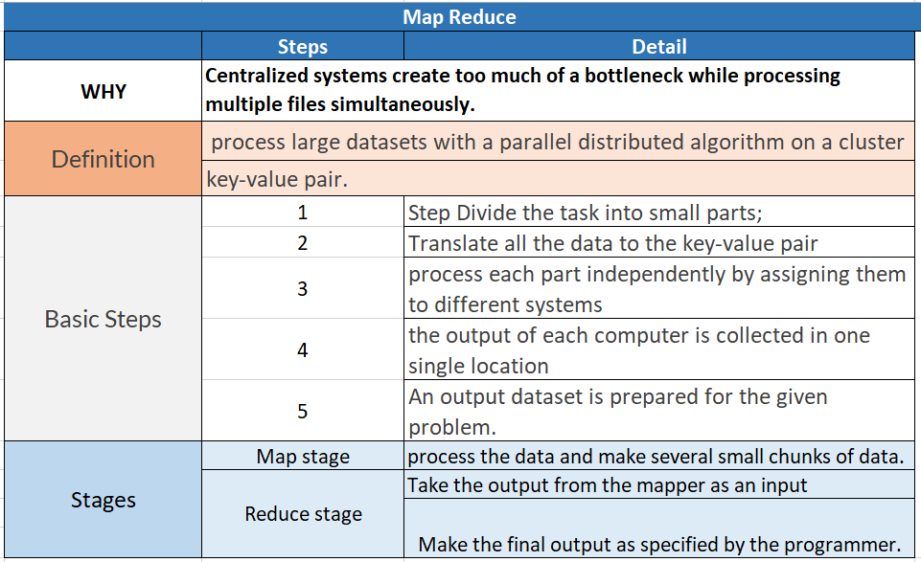

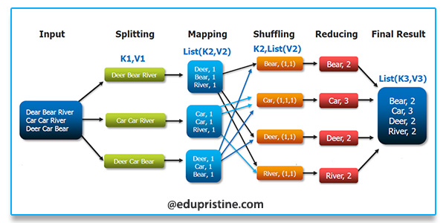

### 7.4.8. Distributed caching:

Distributed caching for scability:

* It's commonly used in cloud computing and virtualized environments
* Different servers give a portion of their cache memory into a pool which can be accessed by virtual machines.

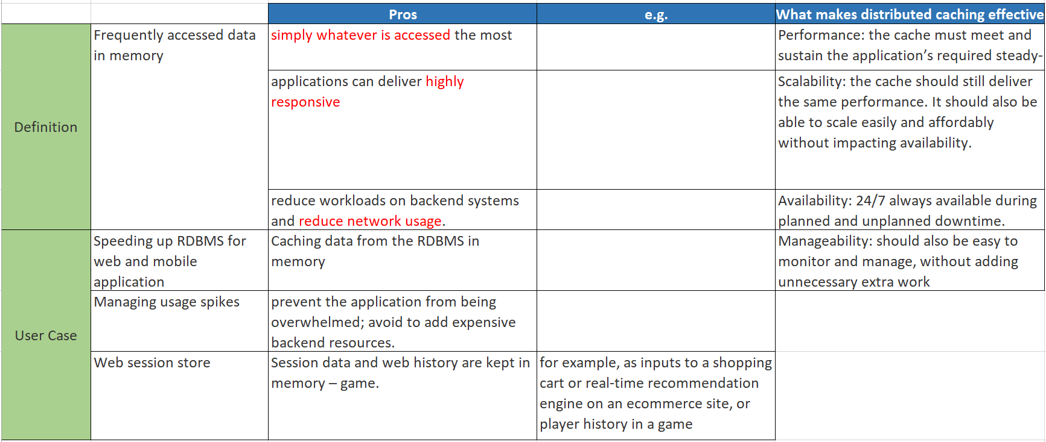

### 7.4.9. Load balancing

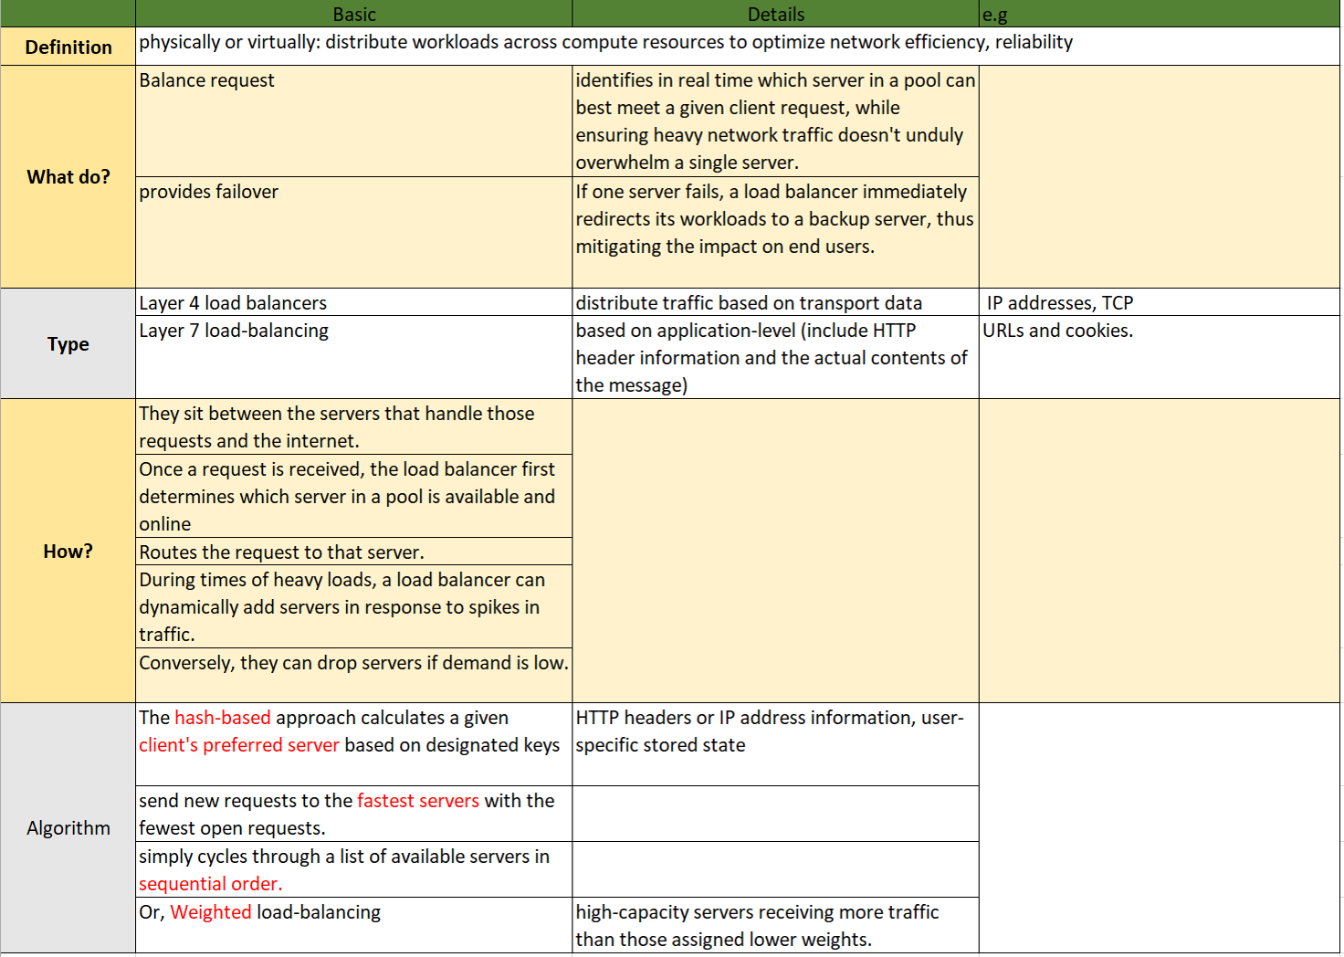

## 7.5 TECHQ_CODE:

## <https://aonecode.com/programming-interview-questions>

### 7.5.1. Memory management work:

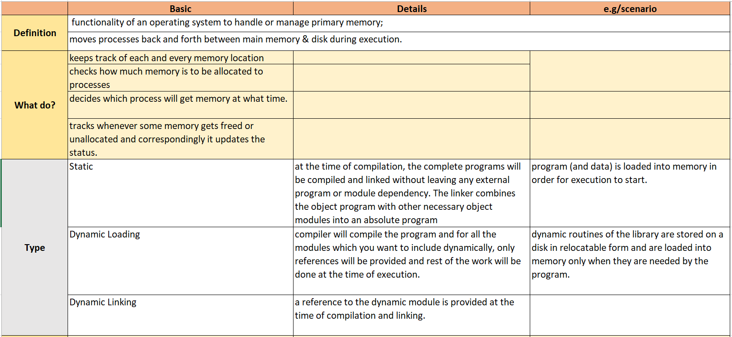 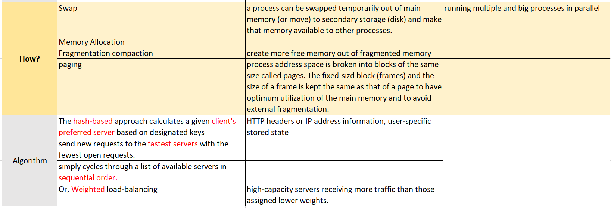

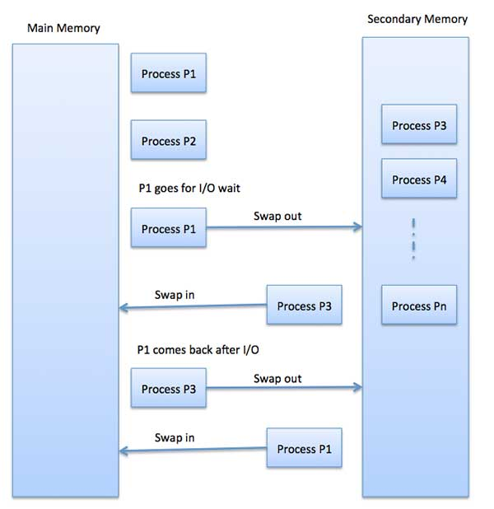

### 7.5.2. The most commonly used collections, libraries

### 7.5.3. Common algorithms:

#### 7.5.3.1 Reverse Linked List:

Input: 1->2->3->4->5->NULL  
Output: 5->4->3->2->1->NULL

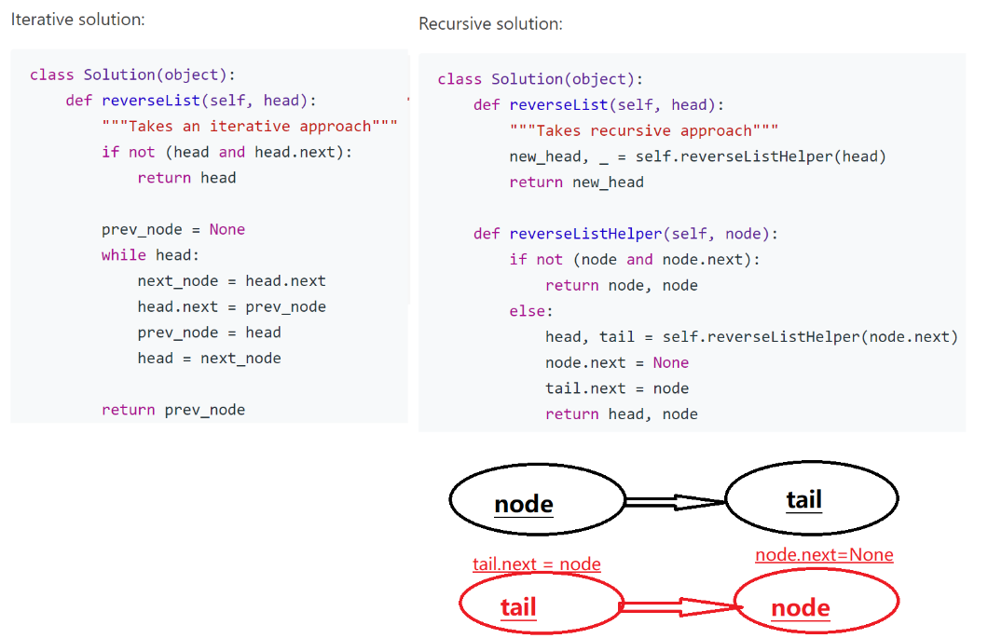

#### 7.5.3.2 Dynamic Programming:

1. Optimality--optimal substructure:

- Proof by induction:

Step 1: Base Case;

Step 2: Induction hypothesis

Step 3: Perform inductive step to proof DP works!

2. e.g: Fabonacci:

Step 1: Base Case: F(0)=0, F(1)=1

Step 2: Induction hypothesis: Assume F(k) is correct for all values of k<=n

Step 3: Perform inductive step:

* From Step 2, F(k-1) is correct for all values of k-1<=n
* Need to solve F(k+1)=F(k)+F(k-1):
  + Because lower k to solve higher k
  + Thus: optimal dynamic programming works for this.

(Have to proof before DP)

2. When no greedy, then DP:

e.g. 1: D={1, 5, 12, 25}, n=16:

Greedy: {12, 1,1,1,1} (not optimal)

DP: {5, 5, 5, 1} (optimal)

* Proof DP:
  + S: optimal for making n cents
  + d: Remove some arbitrary coin (left: n-d for S-{d})
  + S-{d} is optimal for n-d

(If S-{d} is not optimal, another better solution is potential.)

DP Solution for change making:

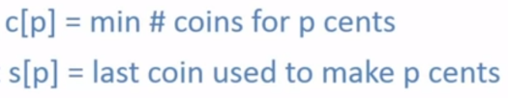

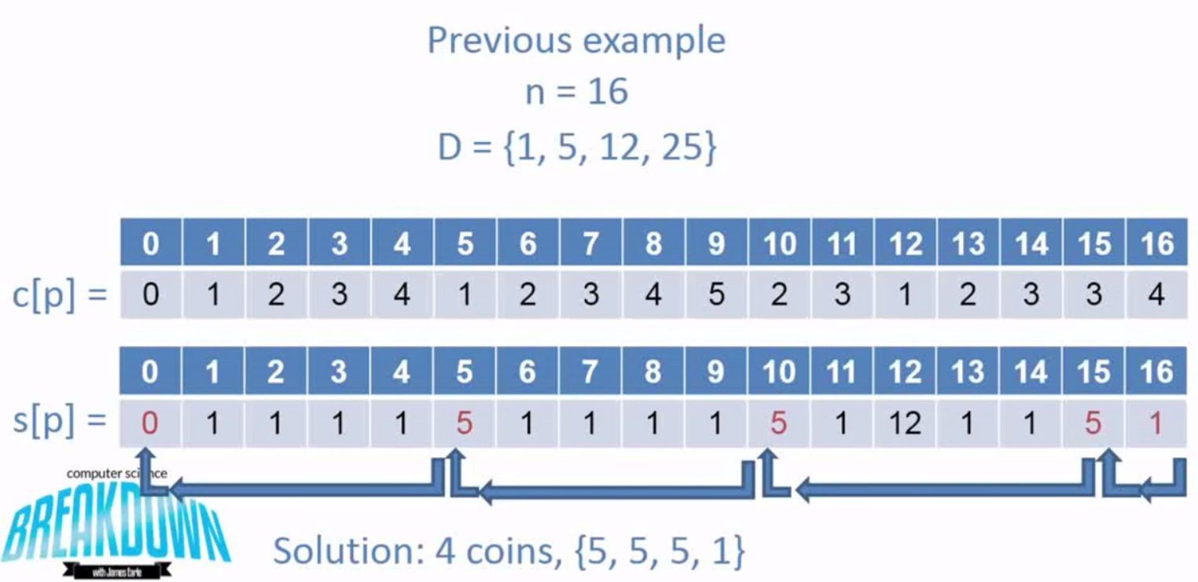

e.g.2: 0/1 Knapsack:

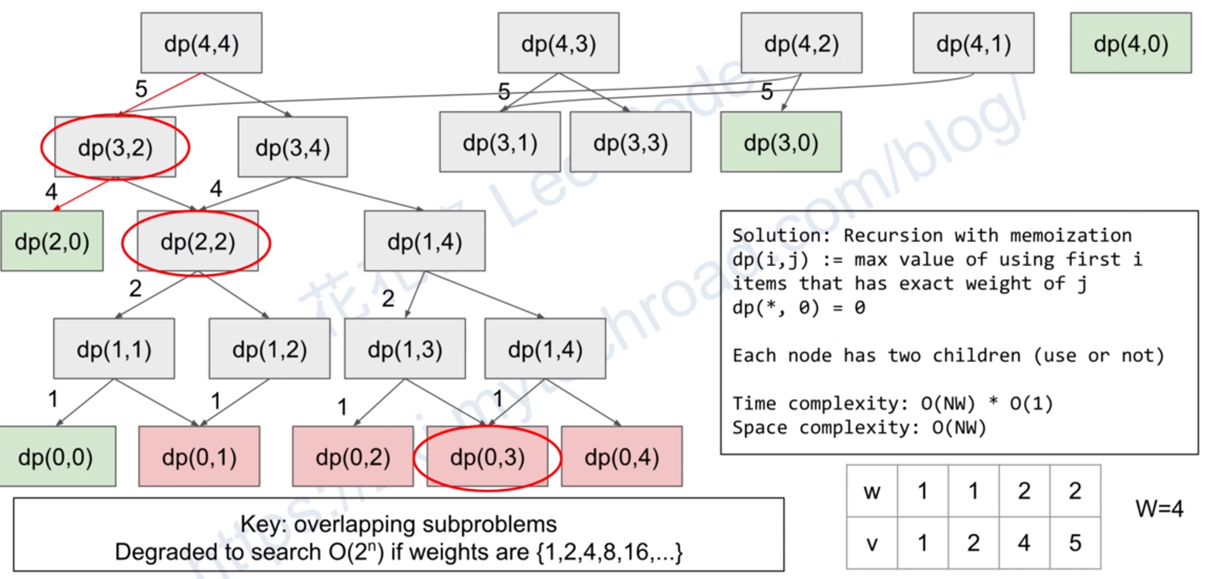 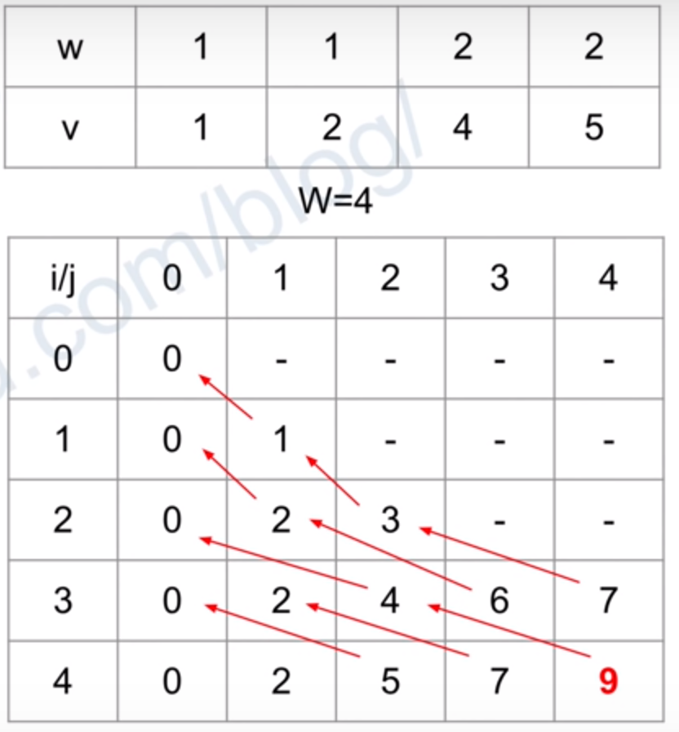

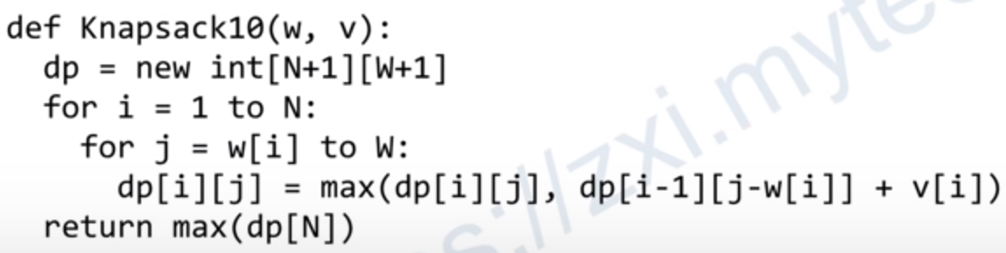

### 7.5.3.1 Traversals:

1. Define a tree:

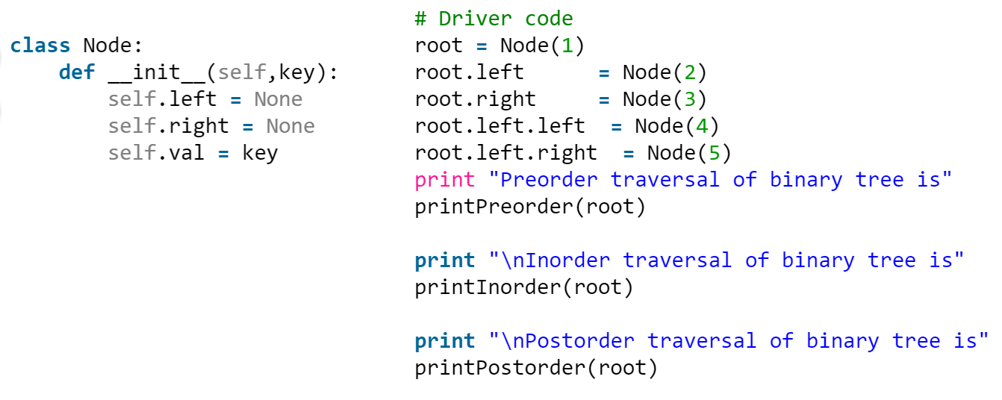

2. Preorder, inorder, postorder:

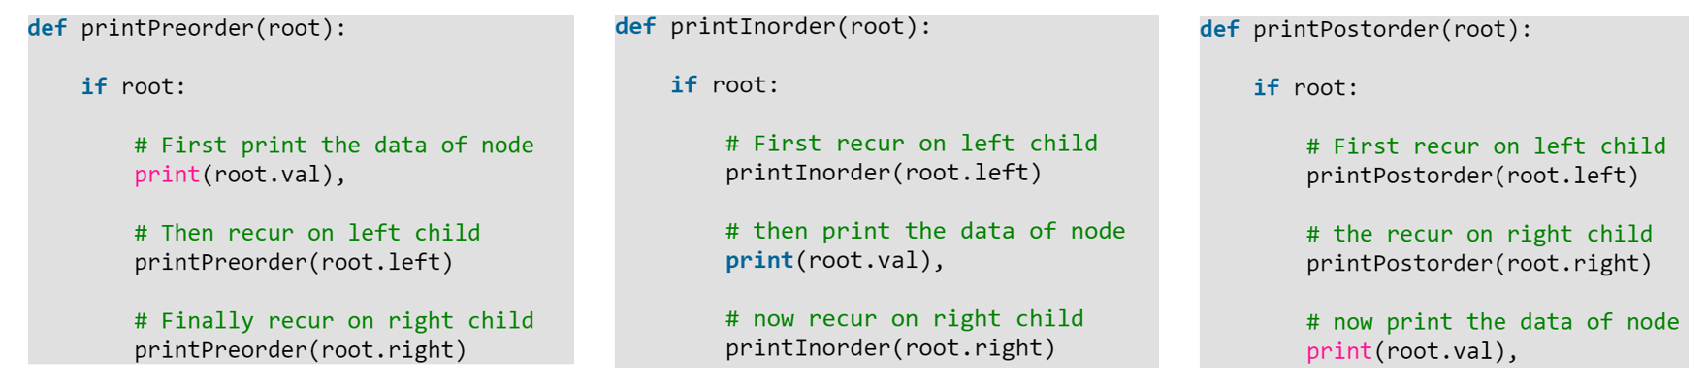

### 7.5.3.2 Divide and conquer:

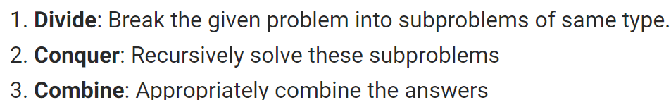

e.g.1: Merge sort:

Step 1: Divide the array into 2 halves;

Step 2: Sort the 2 halves recursively;

Step 3: Merge the 2 sorted halves.

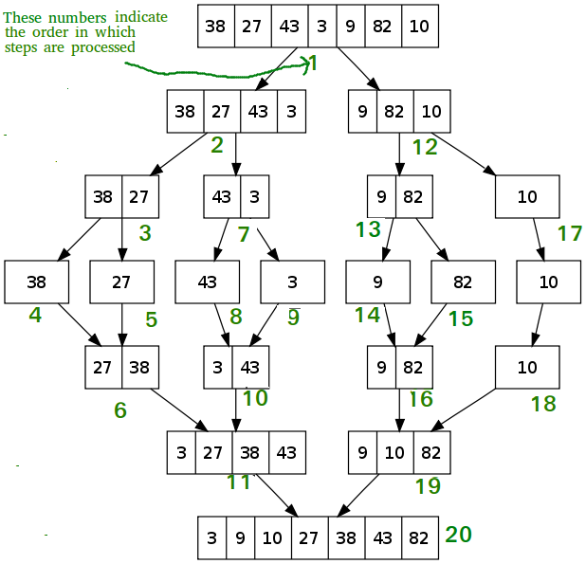

e.g.2: Add all nums:

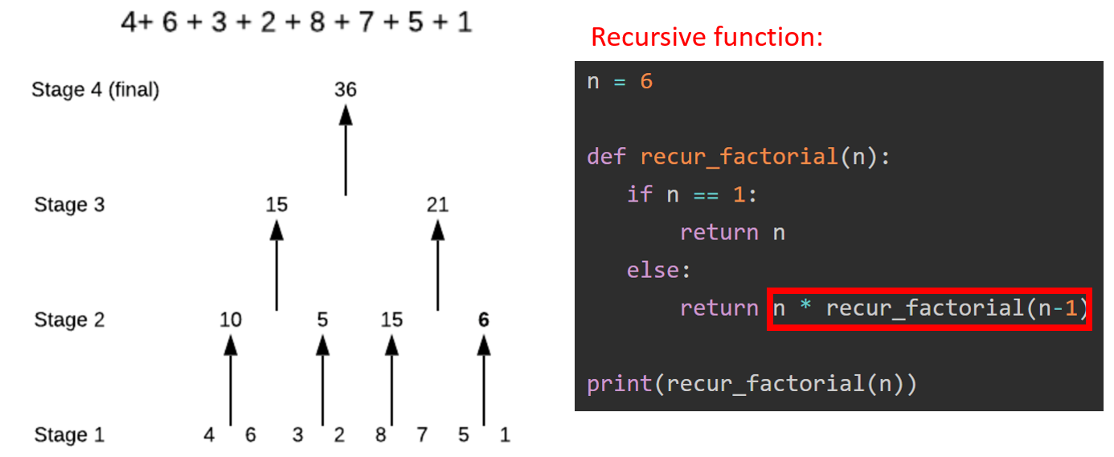

### 7.5.3.3 Breadth-first search vs. depth-first search and understand the tradeoffs for each:

### 7.5.3.4 Knowing the runtimes:

### 7.5.3.5 Theoretical limitations,

### 7.5.3.6 Basic implementation strategies of different classes of algorithms is more important than memorizing the specific details of any given algorithm.

### 7.5.4 Trade-offs between relational and non-relational databases:

## 7.6 TECHQ_Amazon’s most asked interview questions

### 7.6.1 (Heap) [K largest elements from a big file or array](https://www.geeksforgeeks.org/k-largestor-smallest-elements-in-an-array/).

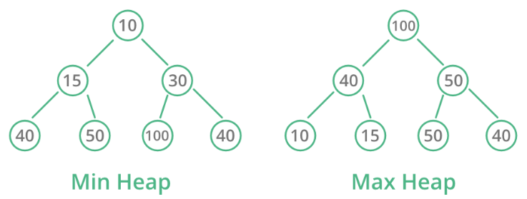

#### 7.6.1.1 Min-heap Meaning:

The property of this data structure in python is that each time the **smallest of heap element is popped(min heap)**.

The heap[0] element also returns the smallest element each time.

#### 7.6.1.2 Heap Operation:

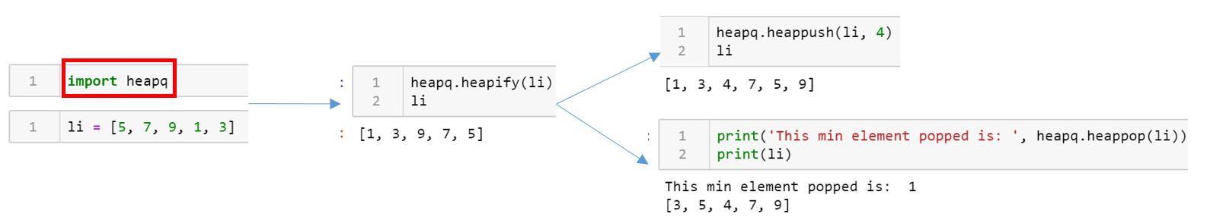

#### 7.6.1.3 Heap VS. BST:

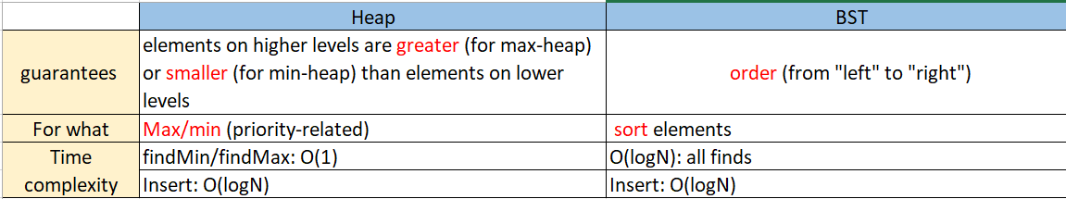

**Plan 1: min-heap:**

* Action:
  + do this by maintaining a min heap of max size k.
  + Every time a new number arrives - check if the heap is smaller then k, if it is - add it.
  + If it is not - check if the minimum is smaller then the new element, and if it is, pop it out and insert the new element instead.
* Result:
  + When you are done - you have a heap containing k largest elements.
  + This solution is O(nlogk) complexity, where n is the number of elements and k is the number of elements you need .

**Plan 2: Split the file and heap:**

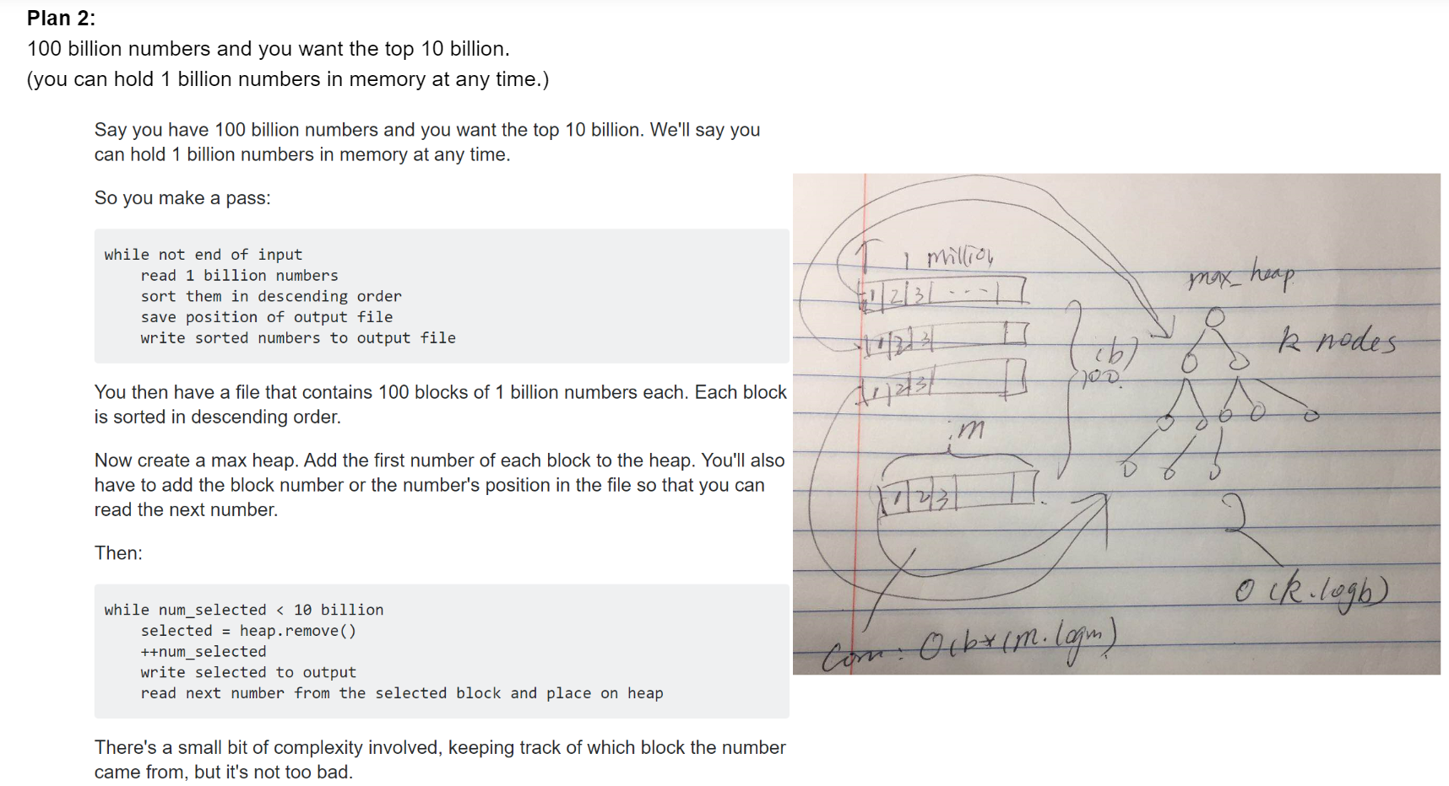

### 7.6.2 (Hashing) [Find a triplet a, b, c such that a^2 = b^2 + c^2](https://www.geeksforgeeks.org/find-pythagorean-triplet-in-an-unsorted-array/).

Variations of this problem like find a triplet with sum equal to 0.

Find a pair with given sum.

All such questions are efficiently solved using hashing.

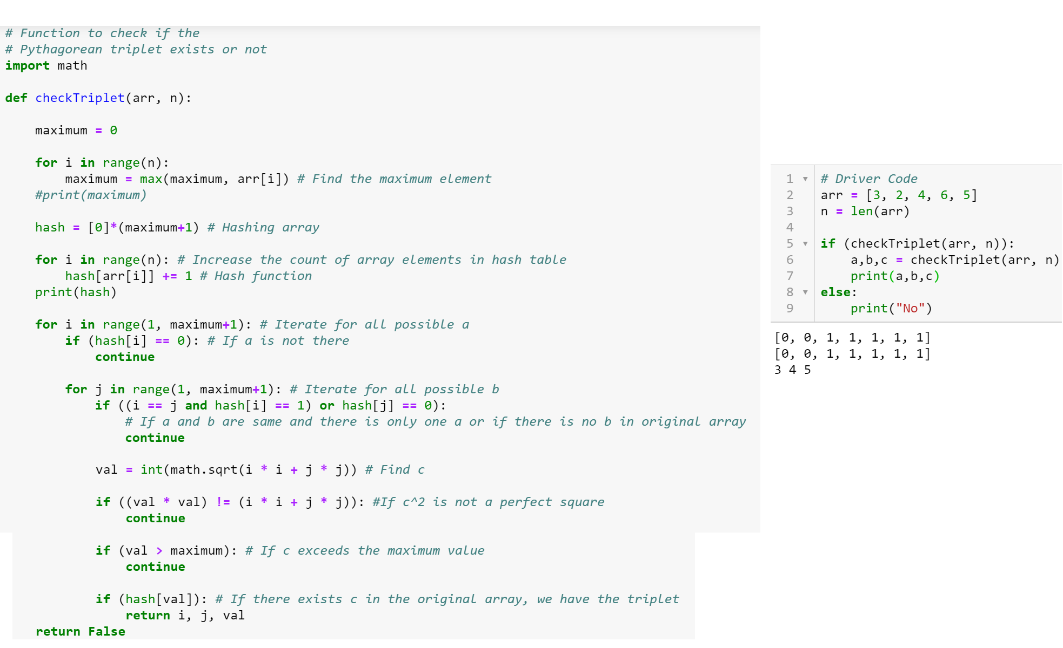

### 7.6.3 Binary [tree traversal questions](http://quiz.geeksforgeeks.org/data-structure/tree-traversals/):

### Left view, right view, top view, bottom view, maximum of a level, minimum of a level, children sum property, diameter etc.

#### 7.6.3.1 Left View:

Hint: The idea is to do level order traversal of the Tree using a queue and print the first node at each level.

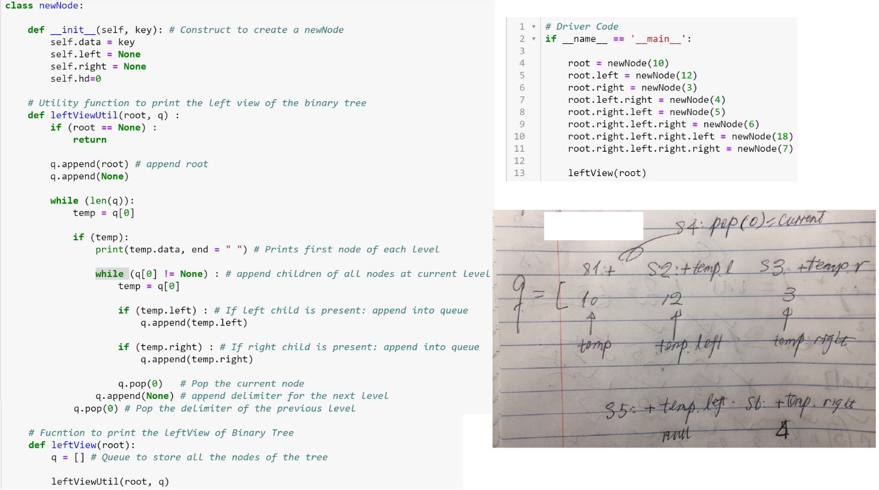

#### 7.6.3.2 Top View:

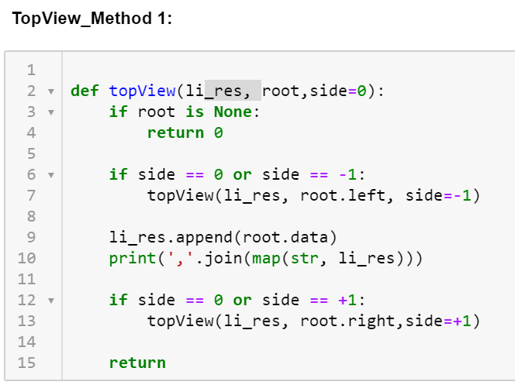

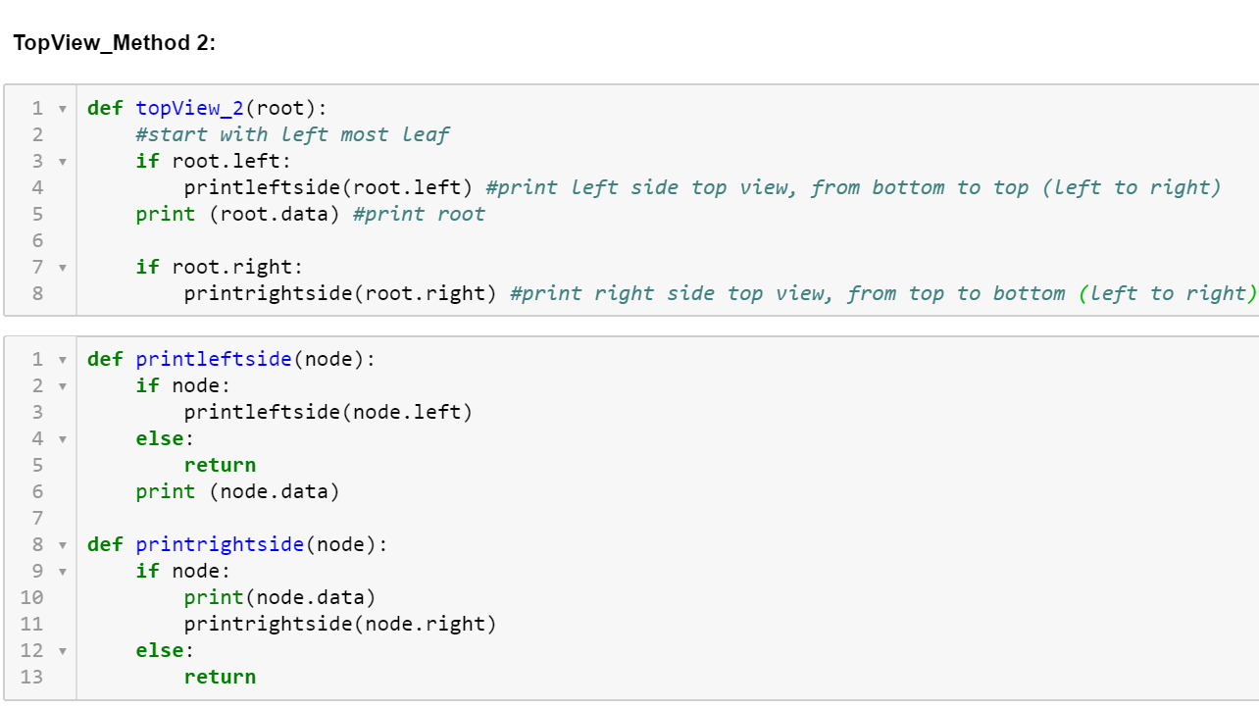

### 7.6.4 [Convert a Binary tree to DLL](https://www.geeksforgeeks.org/convert-a-given-binary-tree-to-doubly-linked-list-set-4/)

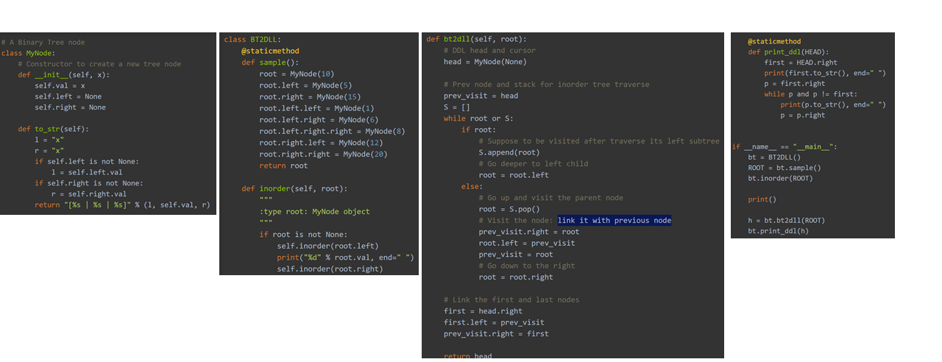

### 7.6.5 [Lowest Common ancestor in a Binary Search Tree and Binary Tree.](https://www.geeksforgeeks.org/lowest-common-ancestor-binary-tree-set-1/)

### 7.6.6 [Implement a stack with push(), pop() and min() in O(1) time.](https://www.geeksforgeeks.org/design-and-implement-special-stack-data-structure/)

### 7.6.7 [Reverse a linked list in groups of size k](https://www.geeksforgeeks.org/reverse-a-list-in-groups-of-given-size/) – Practice [here](https://practice.geeksforgeeks.org/problem-page.php?pid=700013)

### 7.6.8 [Given two numbers represented by two linked lists, write a function that returns sum list](https://www.geeksforgeeks.org/add-two-numbers-represented-by-linked-lists/) – Practice [here](https://practice.geeksforgeeks.org/problem-page.php?pid=700043)

### 7.6.9[Rotate a matrix by 90 degree.](https://www.geeksforgeeks.org/inplace-rotate-square-matrix-by-90-degrees/)

### 7.6.10 [Stock span problem](https://www.geeksforgeeks.org/the-stock-span-problem/)

### 7.6.11 Convert a Tree to linked list:

Root: current node.

Root.right = self.prev: the right part of current node will be updated to(point to) the ‘prev’ part.

Root.left = None: set the left part of current node to be None

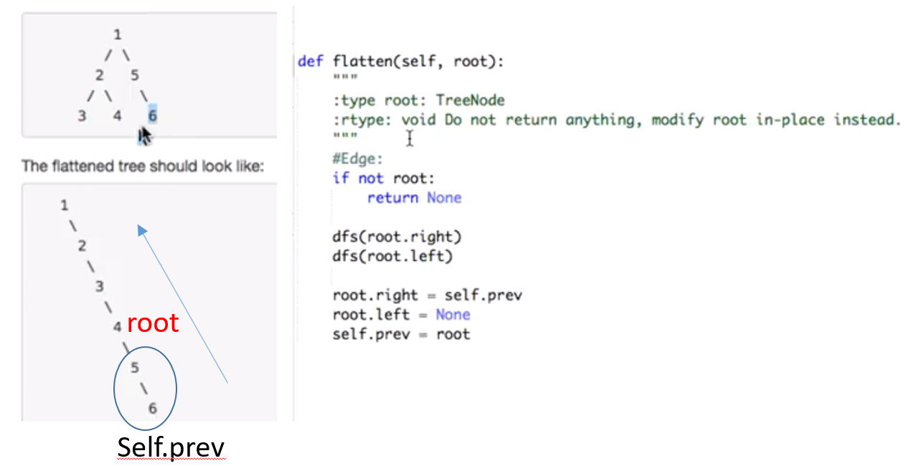

Self.prev = root: update self.prev

### 7.6.12 DFS, BFS:

<https://www.youtube.com/watch?v=7r9zxn6yPbA>

|  |  |  |
| --- | --- | --- |
|  | DFS | BFS  <https://pythoninwonderland.wordpress.com/2017/03/18/how-to-implement-breadth-first-search-in-python/> |
|  |  | BFS implements a specific strategy for visiting all the nodes (vertices) of a graph. |
|  |  | Dictionary + Queue(FIFO):  **Explores nodes one depth level at a time.**   1. Check the starting node and add its neighbors to the queue. 2. Mark the starting node as explored. 3. Get the first node from the queue / remove it from the queue 4. Check if node has already been visited. 5. If not, go through the neighbors of the node. 6. Add the neighbor nodes to the queue. 7. Mark the node as explored. 8. Loop through steps 3 to 7 until the queue is empty.   (The algorithm checks all the nodes at a given depth (distance from the entry point), before moving to the level below.) |
| Application | Traversal  Find path  Number of islands | Traversal  Shortest path |
| Time Complexity | O(n**2) | O(n**2) |
| Space Complexity | O(n**2) | O(n**2) |
| Pros | Min use of space | Always returns the shortest path, even if there is more than one path that links two vertices. (undirected, unweighted) |
| Cons |  | worse is the memory requirements |
|  |  | <https://pythoninwonderland.wordpress.com/2017/03/18/how-to-implement-breadth-first-search-in-python/> |

BFS:

Method 1:

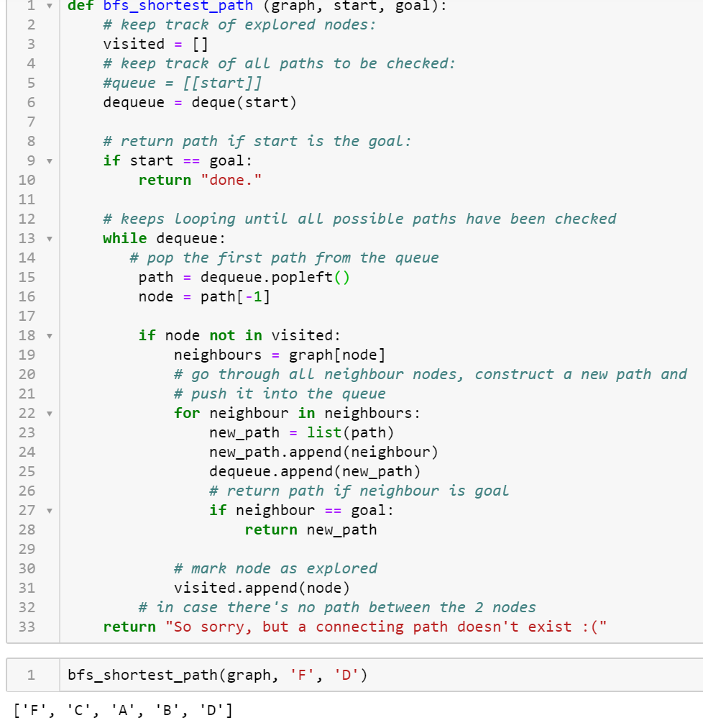

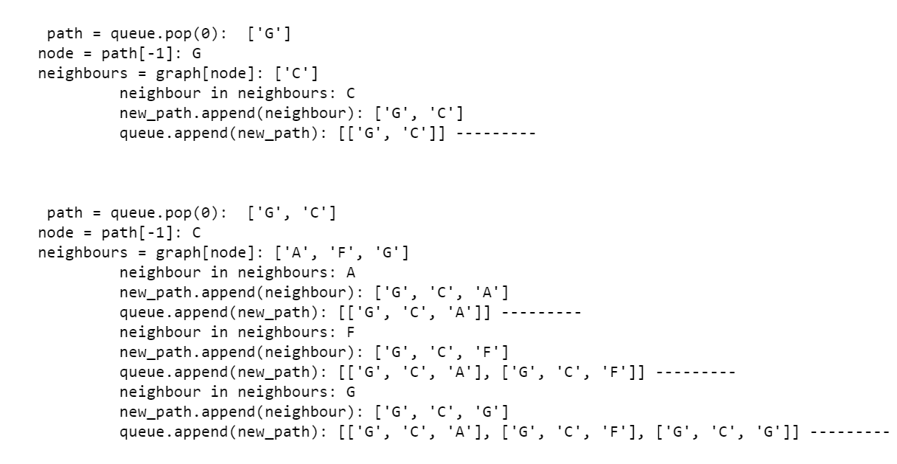 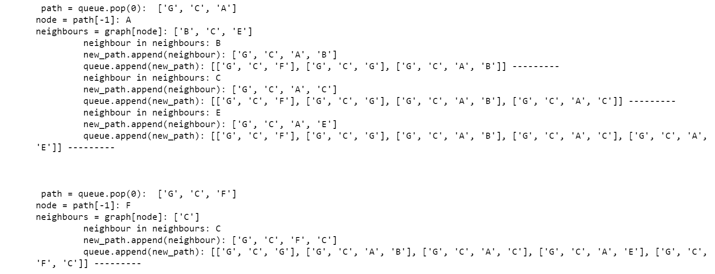

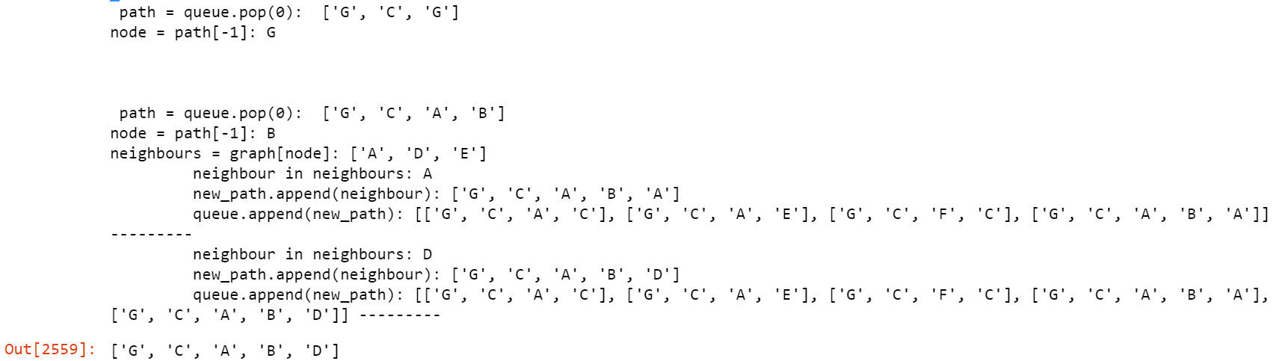

BFS Method 2-Generator method:

* Python generators are a simple way of creating iterators.
* A generator is a function that returns an object (iterator) which we can iterate over (one value at a time).
* It is fairly simple to create a generator in Python. It is as easy as defining a normal function with yield statement instead of a return statement.
* The difference is that, while a return statement terminates a function entirely, yield statement pauses the function saving all its states and later continues from there on successive calls.
* Finally, when the function terminates, StopIteration is raised automatically on further calls. (It automatically ends when StopIteration is raised.)
* One final thing to note is that we can use generators with [for loops](https://www.programiz.com/python-programming/for-loop) directly.

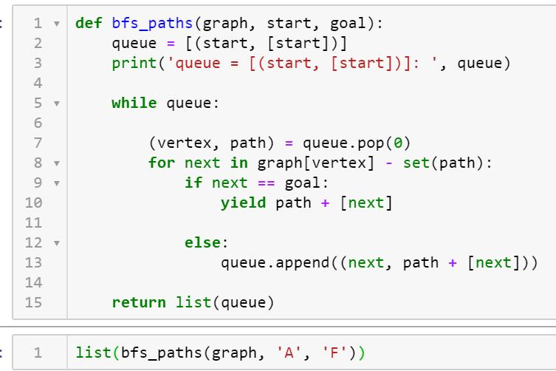

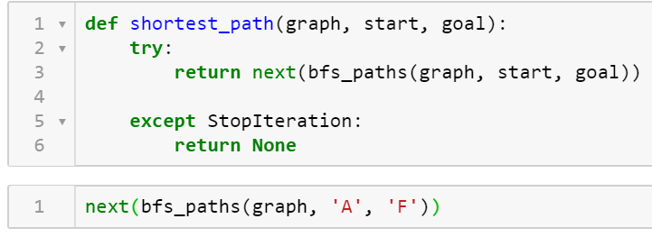

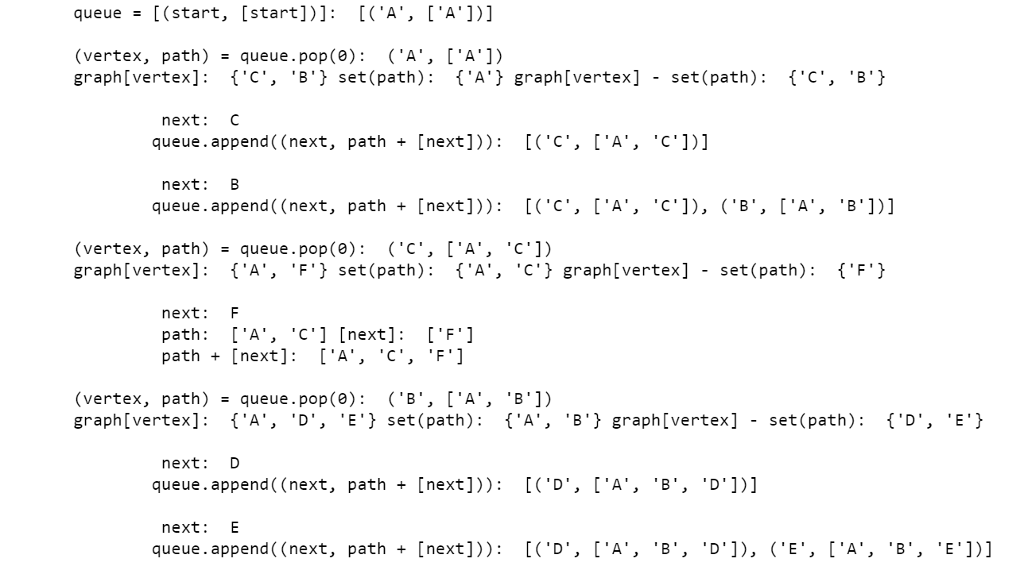 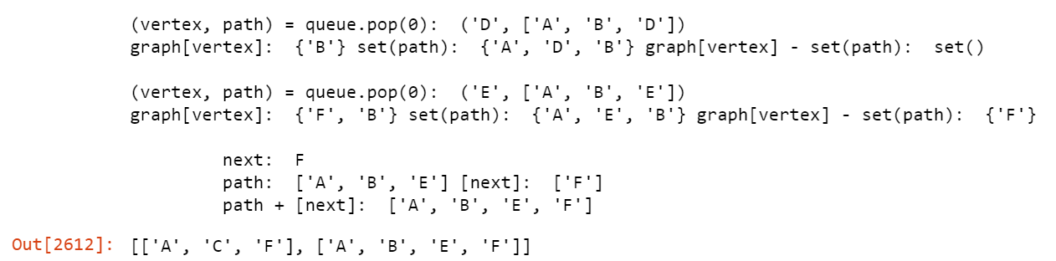

DFS:

<https://eddmann.com/posts/depth-first-search-and-breadth-first-search-in-python/>

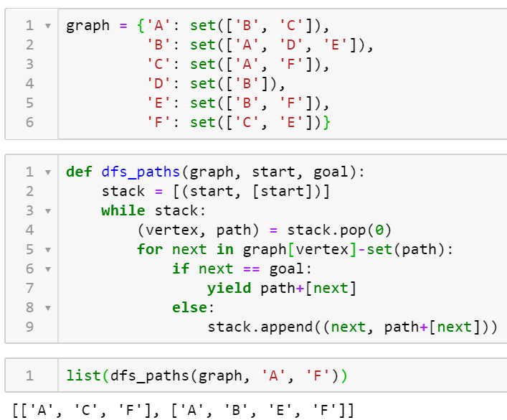

## 7.7 TECHQ_OS:

### 7.7.1 Processes:

### 7.7.2 Threads:

### 7.7.3 Synchronization:

### 7.7.4 Paging:

Paging is a memory management technique in which process address space is broken into blocks of the same size called **pages** (size is power of 2, between 512 bytes and 8192 bytes).

The size of the process is measured in the number of pages.

Similarly, main memory is divided into small fixed-sized blocks of (physical) memory called **frames.**

The size of a frame is kept the same as that of a page to have optimum utilization of the main memory and to avoid external fragmentation.

### Paging

### 7.7.5 Multithreading:

## 7.8 TECHQ_Network:

### 7.8.1. DNS lookup:

It returns details about the specified record type(s) as well as additional useful information about the domain's DNS entries.

For the A record type, a DNS lookup provides information about how the domain or host name is resolved to an IP address (example, 192.168.1.1).

(DNS: It also translates domain names(dnsstuff.com) to IP addresses and records the mail servers that accept mail for each domain.)

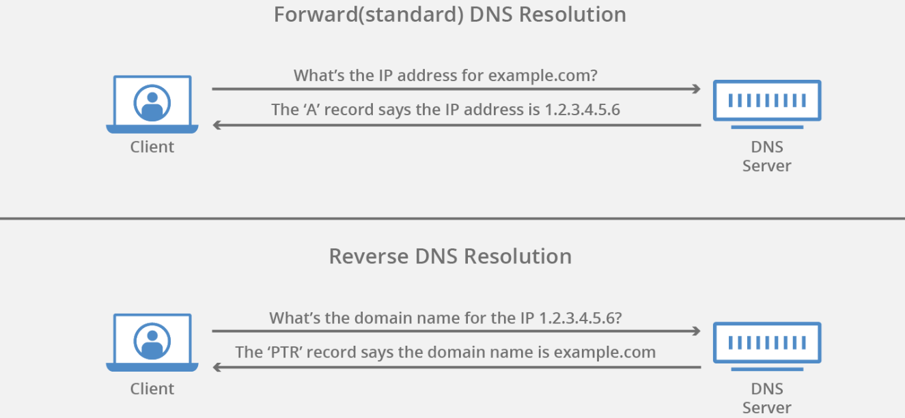

### 7.8.2. Socket connection:

* DefaultDict: store the graph;
* Stack: for saving the nodes and its adjacent for popping.
* 